Name

Mathematics Advanced Year 11
Calculations with the Derivative

Book 1 |  | Version: 260825  Feedback:  https://MrDingMaths.com
Contents
Syllabus Content 2
Derivative Notation 3
Power Rule 4
Power Rule with Negative and Fractional Indices 9
The Derivative is the Gradient of the Tangent 15
Equation of the Tangent and Normal 25
Chain Rule 32
General Power Rule 36
Product Rule 44
Quotient Rule 49
Mixed Practice 54
Applications of Differentiation to Geometry Problems 65

Syllabus Content
MAV-11-06 interprets the meaning of the derivative and determines the derivative of functions to solve problems
Calculations with the derivative
- Use the notation $\frac{dy}{dx}$ and $y'$ for the derivative of $y$ when $y$ is a function of $x$
- Use the notation $\frac{d}{dx}\left(f\left(x\right)\right)$ and $f'(x)$ for the derivative of a function $f\left(x\right)$
- Use the formula $\frac{d}{dx}(x^{n})=nx^{n-1}$ for all real values of $n$
- Apply the fact that the derivative of a sum is the sum of the derivatives: $\frac{d}{dx}\left(f\left(x\right)+g\left(x\right)\right)=f'\left(x\right)+g'(x)$, and the derivative of a multiple of a function is the multiple of its derivative: $\frac{d}{dx}(k⋅f\left(x\right))=k⋅f'(x)$
- Use the rules for differentiation to find equations of tangents and normals to a curve at points on the curve
- Find points on a curve where the tangent or normal has a given gradient
- Examine and use the relationship between the angle of inclination of a line or tangent to a curve, $θ,$ with the positive $x$-axis, and the gradient, $m$, of that line or tangent, and establish that $\tan{θ}=m$
- Apply the product rule: if $y=uv$, where $u$ and $v$ are both differentiable functions of $x$, then $\frac{dy}{dx}=u\frac{dv}{dx}+v\frac{du}{dx}$ or if $h(x)=f(x)g(x)$ for differentiable functions $f(x)$ and $g(x)$ then $h'\left(x\right)=f\left(x\right)g'\left(x\right)+f'\left(x\right)g(x)$
- Apply the quotient rule: if $y=\frac{u}{v}$, where $u$ and $v$ are both functions of $x,$ then $\frac{dy}{dx}=\frac{v\frac{du}{dx}-u\frac{dv}{dx}}{v^{2}}$ or if $h\left(x\right)=\frac{f\left(x\right)}{g\left(x\right)}$ then $h'\left(x\right)=\frac{g\left(x\right)f^{'}\left(x\right)-f\left(x\right)g^{'}\left(x\right)}{[{g\left(x\right)]}^{2}}$
- Apply the chain rule: if$y$ is a differentiable function of $u$, and $u$ is a differentiable function of $x$, then $\frac{dy}{dx} = \frac{dy}{du}×\frac{du}{dx}$ or if $h\left(x\right)=f\left(g\left(x\right)\right)$ for differentiable functions $f(x)$ and $g(x)$ then $h'\left(x\right)=f'\left(g\left(x\right)\right)g'\left(x\right)$
- Identify and apply the product, quotient or chain rule, or a combination of the rules, as appropriate to differentiate a given function

Derivative Notation
- Calculus uses different notation systems depending on the situation.
- All systems are acceptable.
- Lagrange’s notation is the most concise.
- Leibniz's notation works best when your equations have multiple variables, which is common in application problems.
- Leibniz's notation appears on your reference sheet.
- Notation for the Derivative
 | Lagrange’s notation | Leibniz’s notation
$$y=x^{2}$$ | $$y^{'}=2x$$ | $$\frac{dy}{dx}=2x$$
$$f\left(x\right)=x^{2}$$ | $$f^{'}\left(x\right)=2x$$ | $$\frac{d}{dx}\left(x^{2}\right)=2x or \frac{df}{dx}=2x$$

- Interpret differentiation notation.
A function is given. Write the derivative in Lagrange and Leibniz notation.
Function | Lagrange notation | Leibniz notation
$$y=x^{2}$$
$$f\left(x\right)=x^{2}$$
$$g\left(x\right)=x^{2}$$
$$g\left(t\right)=t^{2}$$
$$A\left(r\right)=r^{2}$$
$$A=x^{2}$$

Power Rule

- Review
- Identify the coefficient and power of $x$ for a term.
- $x^{3}$  Coefficient:  Power: | - $-5x^{7}$  Coefficient:  Power: | - $4^{3}x^{9}$  Coefficient:  Power:
- $x$  Coefficient:  Power: | - $\frac{x^{8}}{3}$  Coefficient:  Power: | - $-\frac{x^{7}}{13}$  Coefficient:  Power:
- $-12x$  Coefficient:  Power: | - $\frac{2x^{3}}{5}$  Coefficient:  Power: | - $16$  Coefficient:  Power:

- Power Function
A power function has a single term in the form:
real constants

$$f\left(x\right)=kx^{n}$$

- Identify power functions
✖  $$2^{x}$$ | ✔  $$x^{2}$$ | ✔  $$\frac{t^{-7}}{3}$$ | ✔  $$-2x^{\frac{3}{5}}$$ | ✖  $${\left(-2x+1\right)}^{\frac{3}{5}}$$
Identify which of the following are power functions.
- $x^{3}$ | - $3^{x}$ | - $8x^{15}$ | - $-9t^{7.5}$ | - ${\left(2x+1\right)}^{3}$
- $\sin{x}$ | - $πx$ | - $\frac{d^{3}}{5}$ | - $7$ | - $8x^{-\frac{4}{5}}$

- Power Rule
The power rule is a shortcut for finding the derivative of a power function.
Multiply by the power, reduce the power by 1.

$$f\left(x\right)=kx^{n} \\ f^{'}\left(x\right)=nkx^{n-1}$$

- Identify the derivative of a power function.
$$f\left(x\right)=5x^{10}$$  $$f^{'}\left(x\right)=50x^{9}$$ | $$f\left(x\right)=2x^{10}$$  $$f^{'}\left(x\right)=20x^{9}$$ | $$f\left(x\right)=2x^{6}$$  $$f^{'}\left(x\right)=12x^{5}$$
Differentiate these functions.
- $f\left(x\right)=10x^{7}$ | - $f\left(x\right)=5x^{7}$ | - $f\left(x\right)=5x^{-7}$
- $f\left(x\right)=x^{7}$ | - $f\left(x\right)=10x^{\frac{1}{2}}$ | - $f\left(x\right)=ax^{n}$
- $f\left(x\right)=-5x^{2}$ | - $f\left(x\right)=$ $\frac{x^{3}}{5}$ | - $f\left(x\right)=\frac{x^{-3}}{5}$
- $f\left(x\right)=$ $7$ | - $f\left(x\right)=7x$ | - $f\left(x\right)=$ $\frac{-3x^{-\frac{3}{4}}}{2}$

- Key Ideas
- A power function is a …………… term of the form:
$f\left(x\right)=$ …………, where …… and …… are real constants.
- Power rule is a shortcut for finding the ………………of a …………… function.
- The power rule is: ……………… by the power, reduce the power by ……………
- For a power function $kx^{n},$ the derivative $\frac{d}{dx}\left({kx}^{n}\right)=$ ……………

- Sum Rule of Differentiation
To differentiate a sum or difference of functions, differentiate each term separately.
$$f\left(x\right)=g\left(x\right)+k\left(x\right) \\ f^{'}\left(x\right)=g^{'}\left(x\right)+k^{'}\left(x\right)$$ | $$f\left(x\right)=g\left(x\right)-k\left(x\right) \\ f^{'}\left(x\right)=g^{'}\left(x\right)-k^{'}\left(x\right)$$

- Example Differentiate sums and differences of power functions.
Differentiate $f\left(x\right)=5x^{10}+2x^{7}$  $f^{'}\left(x\right)=50x^{9}+14x^{6}$ | What is the rule for differentiating sums of functions?  Differentiate each term ……………………
Differentiate $f\left(x\right)=5x^{10}-2x^{7}$  $f^{'}\left(x\right)=50x^{9}-14x^{6}$ | What is the rule for differentiating differences of functions?  Differentiate each term ……………………
Differentiate $f\left(x\right)=4x\left(x-3\right)$  $f\left(x\right)=4x^{2}-12x$  $f'\left(x\right)=8x-12$ | What should we do if we see a product of two functions?  Expand brackets so that each term is a  p…………… f………………

- Practice
Differentiate these functions.
- $f\left(x\right)=x^{6}+x^{3}$  $$f^{'}\left(x\right)=6x^{5}+3x^{2}$$ | - $f\left(x\right)=3x^{10}-4x^{9}+2$  $$f^{'}\left(x\right)=30x^{9}-36x^{8}$$ | - $f\left(x\right)=9x-$ $\frac{x^{3}}{5}$  $$f^{'}\left(x\right)=9-\frac{3x^{2}}{5}$$
- $f\left(x\right)=x^{2}-x^{-2}$  $$f^{'}\left(x\right)=2x+2x^{-3}$$ | - $f\left(x\right)=x^{2}(3x+5)$  $$f\left(x\right)=3x^{3}+5x^{2}$$  $$f^{'}\left(x\right)=9x^{2}+10x$$ | - $f\left(x\right)=(x+2)(x+3)$  $$f\left(x\right)=x^{2}+5x+6$$  $$f^{'}\left(x\right)=2x+5$$

- Key Ideas
- For a sum of two functions $f\left(x\right)+g\left(x\right),$the derivative $\frac{d}{dx}\left(f\left(x\right)+g\left(x\right)\right)=$ …………………
- For two functions multiplied, such as $f\left(x\right)=2x\left(x+1\right)$, it is best to ………………………… so that each term is a power function.

Foundation
- Differentiate:
- $f(x)=x⁷$  $$7x⁶$$ | - $f(x)=9x⁵$  $$45x⁴$$ |  | - $f\left(x\right)=\frac{1}{3}x⁶$  $$2x⁵$$
- $f(x)=3x²-5x$  $$6x-5$$ | - $f(x)=x⁴+x²+x+1$  $$4x³+2x+1$$ |  | - $f(x) = 2 - 3x - 5x³$  $$-3 - 15x²$$
- $f(x)=\frac{x^{6}}{3}-\frac{x^{4}}{2}+x²-2$  $$2x⁵-2x³+2x$$ |  | - $f(x)=\frac{x^{4}}{4}+\frac{x^{3}}{3}+\frac{x^{2}}{2}+x+1$  $$x³+x²+x+1$$

- Differentiate by first expanding brackets.
- $f(x)=3x(4-2x)$  $$12-12x$$ | - $f(x)=x(x²+1)$  $$3x²+1$$ | - $f(x)=x²(3-2x-4x²)$  $$6x-6x²-16x³$$
- $f(x)=(x+4)(x-2)$  $$2x+2$$ | - $f(x)=(2x+1)(2x-1)$  $$8x$$ | - $f(x)=(x-7)²$  $$2x-14$$
- $f(x)=(x²+3)²$  $$4x³+12x$$ | - $f(x)=x(7-x)²$  $$3x²-28x+49$$ | - $f(x)=(x²+3)(x-5)$  $$3x²-10x+3$$

- Differentiate, given $a,b,c,k,l$ are constants.
- $f(x) = ax⁴ - bx² + c$  $$4ax³ - 2bx$$ | - $f(x) = (ax - 5)²$  $$2a²x - 10a$$
- $f(x) = k(ax + b)(ax - b)$  $$2ka^{2}x$$ | - $f(x) = x^{l}$  $$lx^{l-1}$$
- $f(x) = x⁵ᵃ⁺¹$  $$(5a + 1)x⁵ᵃ$$ | - $f(x) = bx³ᵇ$  $$3b²x³ᵇ⁻¹$$

Development
- Calculate the derivative of these functions.
- $y=x^{2}$  $$2x$$ | - $y=x^{2}+3x+6$  $$2x+3$$ | - $y=3x^{2}-2x-5$  $$6x-2$$
- $y=x^{2}+3x$  $$2x+3$$ | - $y=x^{2}+3x+5$  $$2x+3$$ | - $y=3x^{3}-2x^{2}-5x$  $$9x^{2}-4x-5$$
- $y=x^{2}-3x$  $$2x-3$$ | - $y=x^{2}+2x+5$  $$2x+2$$ | - $y=2x^{3}-2x^{2}-5x$  $$6x^{2}-4x-5$$
- $y=x^{2}-5x$  $$2x-5$$ | - $y=x^{2}+x-5$  $$2x+1$$ | - $y=2x^{3}+2x^{2}-5x$  $$6x^{2}+4x-5$$
- $y=x^{2}-5$  $$2x$$ | - $y=x^{2}-x-5$  $$2x-1$$ | - $y=2x^{3}+2-5x$  $$6x^{2}-5$$
- $y=x^{2}+5$  $$2x$$ | - $y=x^{2}-2x-5$  $$2x-2$$ | - $y=3x^{3}-5x+2$  $$6x^{2}-5$$
- $y=x^{2}+6$  $$2x$$ | - $y={2x}^{2}-2x-5$  $$4x-2$$ | - $y=2-5x-2x^{3}$  $$-5-6x^{2}$$

- Find the derivative of:
- $\frac{x^{2}}{6}$ $-x$  $$\frac{x}{3}-1$$ | - $\frac{x^{4}}{2}$ $-$ $\frac{x^{3}}{3}$ $+4$  $$2x^{3}-x^{2}$$ | - $\frac{1}{3}$ $x^{6}\left(x^{2}-3\right)$  $$\frac{8x^{7}}{3}-6x^{5}$$
- $\frac{2x^{3}+5x}{x}$  $$4x$$ | - $\frac{x^{2}+2x}{4x}$  $$\frac{1}{4}$$ | - $\frac{3x^{5}-3x^{4}+6x^{3}-2x^{2}}{3x^{2}}$  $$3x^{2}-2x+2$$

Power Rule with Negative and Fractional Indices

- Review
- Subtract 1 from fractions.
- $\frac{1}{2}-1$ | - $\frac{3}{2}-1$ | - $\frac{5}{3}-1$ | - $\frac{1}{3}-1$

- Rewrite fractions in index form.
- $\frac{1}{x}$ | - $\frac{1}{x^{2}}$ | - $\frac{3}{x^{5}}$ | - $-\frac{3}{2x^{4}}$

- Rewrite negative indices in fraction form.
- $x^{-2}$ | - $x^{-3}$ | - $5x^{-1}$ | - $\frac{x^{-2}}{3}$

- Rewrite surds in index form.
- $\sqrt{x}$ | - $\sqrt[3]{x}$ | - $\sqrt[3]{x^{5}}$ | - $x\sqrt{x}$
- $\frac{1}{\sqrt{x}}$ | - $\frac{x}{\sqrt[3]{x}}$ | - $\frac{x^{2}}{\sqrt{x}}$ | - $\frac{x^{5}}{x\sqrt{x^{3}}}$

- Rewrite fractional indices in surd form.
- $x^{\frac{1}{2}}$ | - $x^{\frac{1}{3}}$ | - $x^{\frac{3}{4}}$ | - $x^{-\frac{2}{3}}$

- Differentiate power functions.
- $f\left(x\right)=7x^{5}$ | - $f\left(x\right)=3x^{4}-x^{3}+7x$ | - $f\left(x\right)=5x^{6}-8x^{-2}$

- Power Rule for Negative and Fractional Indices
- Split fractions with many terms in the numerator and a single $x$ term in the denominator.
- Rewrite fractions or surds using index form
- Differentiate using power rule $\frac{d}{dx}\left(x^{n}\right)=nx^{n-1}$.
- Rewrite your answer as a fraction or surd.

- Example Differentiate power functions involving negative indices
Differentiate $f\left(x\right)=$ $\frac{6}{x^{3}}$  $$1. f\left(x\right)=6x^{-3}$$  $$2. f^{'}\left(x\right)=-18x^{-4}$$  $$3. =-\frac{18}{x^{4}}$$ | What should we do when we see a power of $x$ in the denominator?  Rewrite as a n………………… index.
Differentiate $f\left(x\right)=$ $\frac{5+x^{2}}{x^{3}}$  $$0. f\left(x\right)=\frac{5}{x^{3}}+\frac{x^{2}}{x^{3}}$$  $$1. f\left(x\right)=5x^{-3}+x^{-1}$$  $$2. f^{'}\left(x\right)=-15x^{-4}-x^{-2}$$  $$3. =-\frac{15}{x^{4}}-\frac{1}{x^{2}}$$ | What should we do when we see many terms in the numerator and a single $x$ term in the denominator?  …………… the fraction into individual terms.

- Practice
Differentiate:
- $f\left(x\right)=5x^{-3}$  $$f^{'}\left(x\right)=-\frac{15}{x^{4}}$$ | - $f\left(x\right)=$ $\frac{2}{x^{4}}$  $$f^{'}\left(x\right)=-\frac{8}{x^{5}}$$ | - $f\left(x\right)=$ $-\frac{1}{4x^{2}}$  $$f^{'}\left(x\right)=\frac{1}{2x^{3}}$$
- $f\left(x\right)=$ $\frac{16}{x^{5}}-\frac{24}{x^{2}}$  $$f^{'}\left(x\right)=-\frac{80}{x^{6}}+\frac{48}{x^{3}}$$ | - $f\left(x\right)=$ $\frac{x^{3}+x^{2}+x}{x}$  $$f\left(x\right)=x^{2}+x+1$$  $$f^{'}\left(x\right)=2x+1$$ | - $f\left(x\right)=$ $\frac{5-x^{2}+5x^{4}}{x^{2}}$  $$f\left(x\right)=\frac{5}{x^{2}}-1+5x^{2}$$  $$f^{'}\left(x\right)=-\frac{10}{x^{3}}+10x$$

- Example Differentiate power functions involving fractional indices.
Differentiate $f\left(x\right)=7\sqrt{x}$  $$1. f\left(x\right)=7x^{\frac{1}{2}}$$  $$2. f^{'}\left(x\right)=\frac{7}{2}x^{-\frac{1}{2}}$$  $$3. =\frac{7}{2\sqrt{x}}$$ | What should we do when we see $x$ inside a surd?  Rewrite as a f………………… index.
Differentiate $f\left(x\right)=$ $\frac{5x^{2}}{\sqrt{x}}$  $$1. f\left(x\right)=\frac{5x^{2}}{x^{\frac{1}{2}}}$$  $$=5x^{\frac{3}{2}}$$  $$2. f^{'}\left(x\right)=\frac{15}{2}x^{\frac{1}{2}}$$  $$3. =\frac{15\sqrt{x}}{2}$$ | Describe how $\frac{x^{2}}{\sqrt{x}}$ becomes $x^{\frac{3}{2}}$

- Practice
Differentiate
- $f\left(x\right)=x^{\frac{5}{4}}$  $$f^{'}\left(x\right)=\frac{5 \sqrt[4]{x} }{4}$$ | - $f\left(x\right)=5x^{-\frac{1}{2}}$  $$f^{'}\left(x\right)=-\frac{5}{2\sqrt{x^{3}}}$$ | - $f\left(x\right)=5\sqrt{x}$  $$f^{'}\left(x\right)=\frac{5}{2\sqrt{x}}$$
- $f\left(x\right)=\sqrt{16x}$  $$f^{'}\left(x\right)=\frac{2}{\sqrt{x}}$$ | - $f\left(x\right)=$ $\frac{1}{\sqrt{x}}$  $$f^{'}\left(x\right)=-\frac{1}{2\sqrt{x^{3}}}$$ | - $f\left(x\right)=$ $\frac{x^{3}+2x}{\sqrt{x}}$  $$f^{'}\left(x\right)=\frac{5x\sqrt{x}}{2}+\frac{1}{\sqrt{x}}$$

- Key Ideas
- To differentiate fractions with $x$ in the denominator, or surds with $x$ inside the root, rewrite them in ……………… form first, and ……………… any fractions into individual terms.

Foundation
- Use the power rule to find the derivative of each function in index notation.
- $f\left(x\right)=x^{-1}$  $$-x^{-2}$$ | - $f\left(x\right)=x^{-5}$  $$-5x^{-6}$$ | - $f\left(x\right)=3x^{-1}$  $$-3x^{-2}$$
- $f\left(x\right)=5x^{-2}$  $$-10x^{-3}$$ | - $f\left(x\right)=-$ $\frac{4x^{-3}}{3}$  $$4x^{-4}$$ | - $f\left(x\right)=2x^{-2}+$ $\frac{x^{-8}}{2}$  $$-4x^{-3}-4x^{-9}$$

- Write each function using negative indices, differentiate it, then rewrite as a fraction.
- $f\left(x\right)=$ $\frac{1}{x}$  $$-\frac{1}{x^{2}}$$ | - $f\left(x\right)=$ $\frac{1}{x^{2}}$  $$-\frac{2}{x^{3}}$$ | - $f\left(x\right)=$ $\frac{1}{x^{4}}$  $$-\frac{4}{x^{5}}$$ | - $f\left(x\right)=$ $\frac{3}{x}$  $$-\frac{3}{x^{2}}$$

- Find $\frac{dy}{dx}$, leaving your answer in index notation.
- $y=x^{-\frac{1}{2}}$  $$-\frac{1}{2}x^{-\frac{3}{2}}$$ | - $y=x^{\frac{3}{2}}$  $$\frac{3}{2}x^{\frac{1}{2}}$$ | - $y=6x^{\frac{2}{3}}$  $$4x^{-\frac{1}{3}}$$
- $y=12x^{-\frac{1}{3}}$  $$-4x^{-\frac{4}{3}}$$ | - $y=4x^{\frac{1}{4}}+8x^{-\frac{1}{2}}$  $$x^{-\frac{3}{4}}-4x^{-\frac{3}{2}}$$ | - $y=7x^{\frac{7}{3}}$  $$\frac{49}{3}x^{\frac{4}{3}}$$

- Write $y=\sqrt{x}$ as a power of $x$, then show that $\frac{dy}{dx}=\frac{1}{2\sqrt{x}}$.
$$y=x^{\frac{1}{2}}$$
$$\frac{dy}{dx}=\frac{1}{2}x^{-\frac{1}{2}}$$
$$=\frac{1}{2}×\frac{1}{\sqrt{x}}$$
$$=\frac{1}{2\sqrt{x}}$$

Development
- Show that $y=x^{2}\sqrt{x}$ can be written as $y=x^{\frac{5}{2}}$, then show that the derivative is $\frac{dy}{dx}$ $=\frac{5}{2}x\sqrt{x}$

$$y=x^{2}×x^{\frac{1}{2}}=x^{2\frac{1}{2}}=x^{\frac{5}{2}}$$
$$\frac{dy}{dx}=\frac{5}{2}x^{\frac{3}{2}}$$
$$=\frac{5}{2}x^{1}×x^{\frac{1}{2}}$$
$$=\frac{5}{2}x\sqrt{x}$$
- Differentiate each function and write the answer as a surd.
- $y=x\sqrt{x}$  $$\frac{3\sqrt{x}}{2}$$ | - $y=$ $\frac{1}{\sqrt{x}}$  $$-\frac{1}{2x\sqrt{x}}$$ | - $y=$ $\frac{1}{x\sqrt{x}}$  $$-\frac{3}{2x^{2}x}$$

- Use the fact that the derivative of $\sqrt{x}=$ $\frac{1}{2\sqrt{x}}$ to differentiate:
- $f\left(x\right)=3\sqrt{x}$  $$\frac{3}{2\sqrt{x}}$$ | - $f\left(x\right)=10\sqrt{x}$  $$\frac{5}{\sqrt{x}}$$ | - $f\left(x\right)=\sqrt{49x}$  $$\frac{7}{2\sqrt{x}}$$ | - $f\left(x\right)=\sqrt{7x}$  $$\frac{\sqrt{7}}{2\sqrt{x}}$$

- Use the fact that the derivative of $\frac{1}{x}$ is $-\frac{1}{x^{2}}$ to differentiate:
- $f\left(x\right)=$ $\frac{3}{x}$  $$-\frac{3}{x^{2}}$$ | - $f\left(x\right)=$ $\frac{1}{3x}$  $$-\frac{1}{3x^{2}}$$ | - $f\left(x\right)=-$ $\frac{7}{3x}$  $$\frac{7}{3x^{2}}$$ | - $f\left(x\right)=$ $\frac{a}{x}$  $$-\frac{a}{x^{2}}$$

Mastery
- Expand brackets, then differentiate.
$$y={\left(x+\frac{1}{x}\right)}^{2}$$  $$2x-2x^{-3}$$ | $$y={\left(1+\frac{1}{x}\right)}^{2}-{\left(x-\frac{1}{x}\right)}^{2}$$  $$-\frac{2}{x^{2}}-2x$$ | $$y={\left(\sqrt{x}-\frac{1}{\sqrt{x}}\right)}^{2}$$  $$1-\frac{1}{x^{2}}$$

- Divide each term in the numerator by the denominator, then differentiate.
- $y=$ $\frac{x^{3}-3x+8}{x^{2}}$  $$1+3x^{-2}-16x^{-3}$$ | - $y=$ $\frac{x^{2}+6x\sqrt{x}+x}{x}$  $$1+3x^{-\frac{1}{2}}$$ | - $y=$ $\frac{3x-2\sqrt{x}}{\sqrt{x}}$  $$\frac{3}{2}x^{-\frac{1}{2}}$$

The Derivative is the Gradient of the Tangent

- Review
- Recall the definition of the derivative.
Differentiation is the process of finding the d…………………
The derivative is the g………………… of the t……………….
The gradient of the tangent is the d……………………
$f^{'}\left(x\right)$ can be called the d…………………, or the g……………… f………………

- Find the derivative using power rule.
- $f\left(x\right)=x\left(5+x\right)$ | - $f\left(x\right)=x^{2}-5x+11$ | - $f\left(x\right)=5x^{3}-6x$

- Evaluate an expression using function notation.
- $f\left(x\right)=3x^{2}$. Find $f\left(4\right)$. | - $f\left(x\right)=x^{2}+6x$, find $f\left(5\right)$.

- Solve for $x$ when $f\left(x\right)=c$.
- $f\left(x\right)=3x^{2}$. Find $x$ if $f\left(x\right)=12$ | - $f\left(x\right)=x^{2}+6x$, find $x$ if $f\left(x\right)=-9$.

- Convert between angle of inclination and gradient using $m=\tan{θ}$.
- $θ=45°$ | - $θ=135°$ | - $θ=60°$
- $m=2$ | - $m=-$ $\frac{1}{2}$ | - $m=-4$

- Interpret function and differentiation notation.
Consider the function $y=f\left(x\right)$.
For each question, decide whether you’re being asked to:
- Find $f\left(a\right)$: the $y$-coordinate at $x=a$.
- Solve $f\left(x\right)=c$, find $x$ value(s) where the $y$-coordinate is $c$.
- Find $f^{'}\left(a\right):$ the gradient of the tangent at $x=a$.
- Find $f^{'}\left(x\right):$ the gradient function.
- Solve $f^{'}\left(x\right)=m$: find $x$ value(s) where the gradient of $f\left(x\right)$ is $m$.
- Find the gradient of the curve $y=x²$ at the point where $x=3$.

- For the function $f(x)=x^{2}$, find the derivative.

- Given $y=x^{2}$, find the point(s) on the curve when $x=3$.

- Find the $y$-intercept of $y=x^{2}$

- At what point(s) on the curve $y=x^{2}$ is the gradient equal to$3$?

- Find the gradient of the tangent to $y=x^{2}$ at $x=3$.

- What is the $y$-value when $x=3$ for $y=x^{2}.$

- Calculate the slope of the curve $y=x^{2}$ at the point $(3, 9)$.

- Find the point where the tangent to $y=x^{2}$ is horizontal.

- Find $\frac{dy}{dx}$ for $y=x^{2}$.

- What is the $y$-coordinate of the curve $y=x^{2}$ when $x=3$?

- At what value(s) of $x$ does the curve $y=x^{2}$ have a gradient of 3?

- Find the gradient function for $y=x^{2}$.

- Interpret function and differentiation notation graphically.
$f\left(x\right):$ The output of the function for any input $x.$
$f\left(a\right)$: The output of the function at $x=a$.
$f\left(x\right)=c$: Find the $x$-coordinate where the output of the function is $c$.
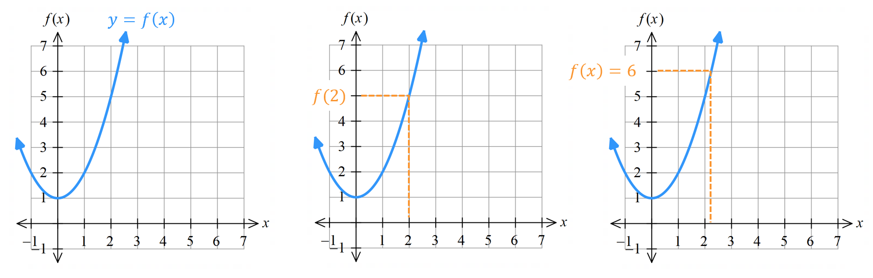

$f^{'}\left(a\right):$ The gradient of the tangent to $f\left(x\right)$ at $x=a$.
$f^{'}\left(x\right)$: The derivative, or gradient function, of $f\left(x\right),$ for any input $x$.
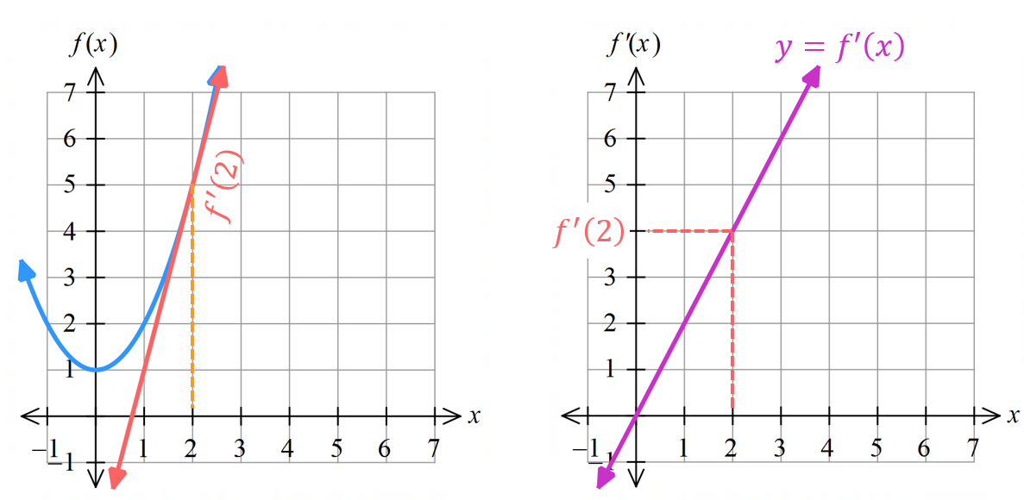

$f^{'}\left(x\right)=m:$ Find the $x$-coordinate where the gradient of the function is $m$.
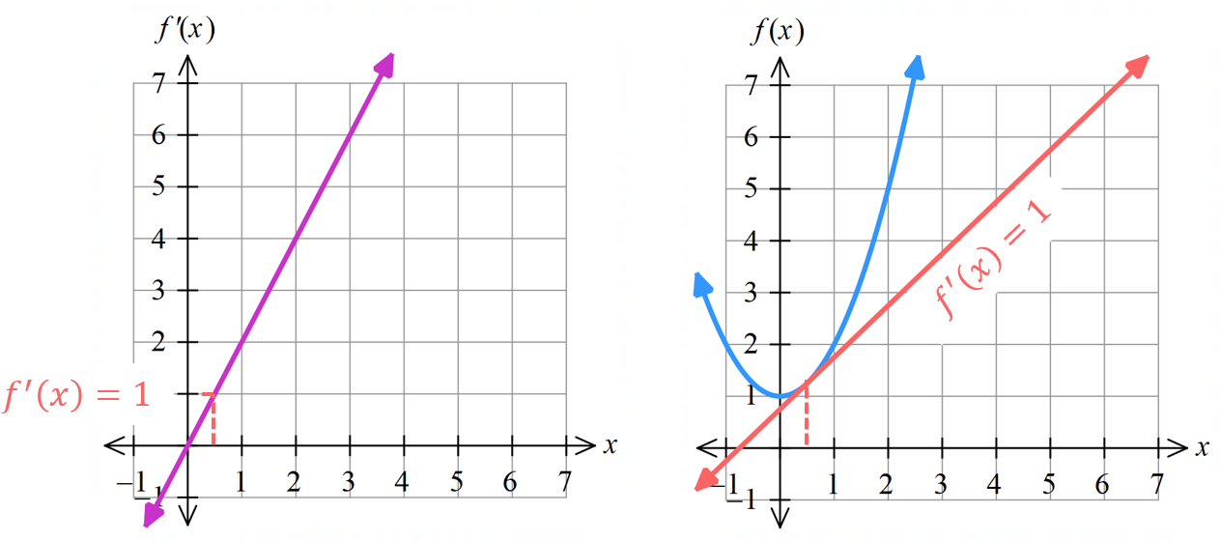

- Interpret function and differentiation notation graphically.
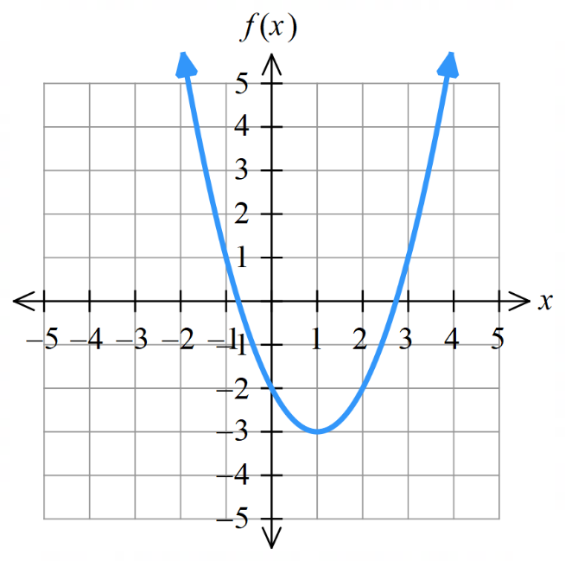
The function $y=f\left(x\right)$ and its gradient function $y=f'\left(x\right)$ have been sketched below.
- Find $f\left(3\right)$

- Find $f^{'}\left(3\right)$

- Sketch a representation of $f^{'}\left(3\right)$on $y=f\left(x\right)$

- Find where $f\left(x\right)=1$

- Find where $f'\left(x\right)=0$
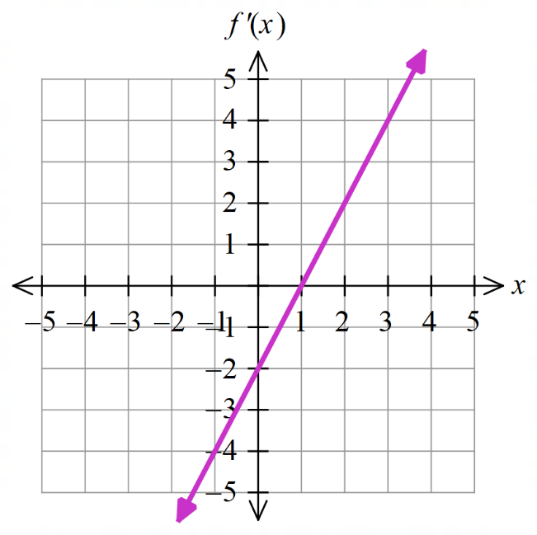
- Find where $f\left(x\right)=-2$

- Find where $f^{'}\left(x\right)=-2$

- Sketch where $f^{'}\left(x\right)=-2$ on $y=f\left(x\right)$

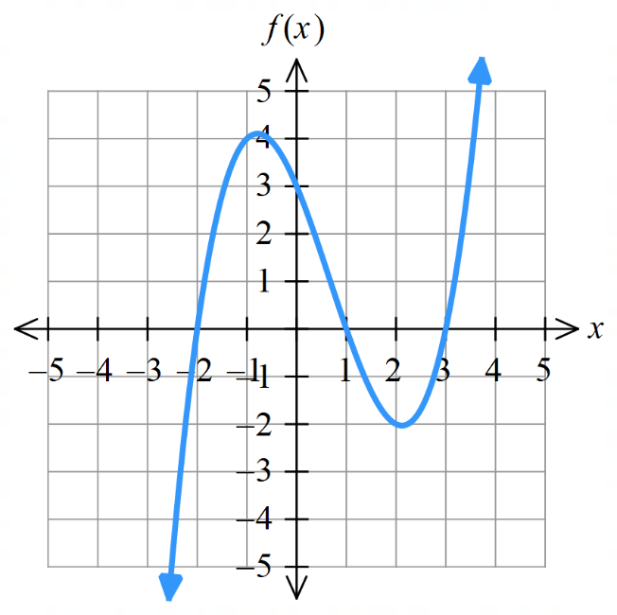
- Find $f\left(1\right)$

- Find $f^{'}\left(1\right)$

- Sketch a representation of $f^{'}\left(1\right)$on $y=f\left(x\right)$.

- Find where $f\left(x\right)=0$

- Find where $f^{'}\left(x\right)=0$

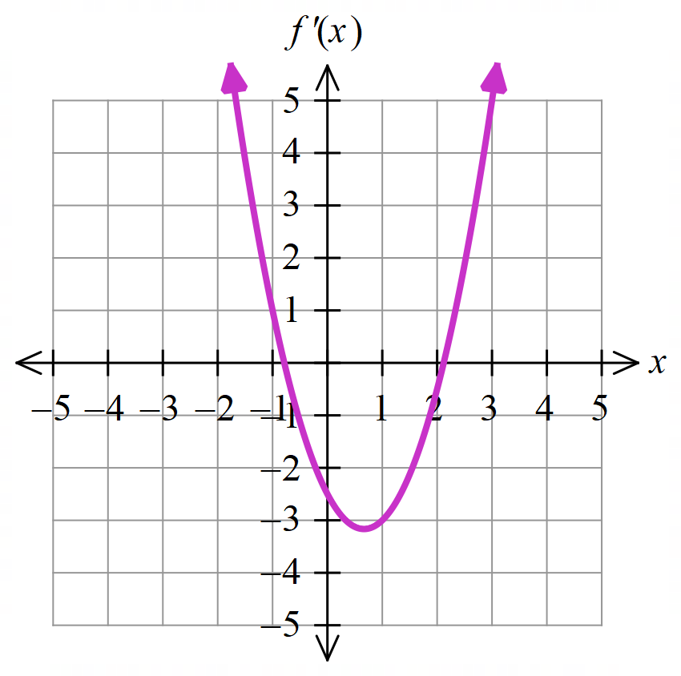
- Sketch where $f^{'}\left(x\right)=0$on $y=f\left(x\right)$.

- Find $f^{'}\left(-1\right)$

- Sketch representation of $f^{'}\left(-1\right)$ on $y=f\left(x\right)$.

- Finding points on a curve with a given gradient
- Find the derivative $f'(x)$.
- Solve the equation $f^{'}\left(x\right)=m$ for $x$.
- Find the $y$-coordinate by substituting $x$ into $f\left(x\right).$

- Example Find points on a curve with a given gradient.
Find the point on $f\left(x\right)=x(6-x)$  where the gradient of the tangent is $0.$  1. Derivative  $$f\left(x\right)=6x-x^{2} \\ f^{'}\left(x\right)=6-2x$$  2. $f'\left(x\right)=m$  Let $f^{'}\left(x\right)=0$  $$6-2x=0 \\ x=3$$  3. Find $y$-coordinate  $$f\left(3\right)=18-9 \\ ∴y=9$$  The gradient of the tangent is 0 is at $\left(3,9\right).$ | Draw the tangent at the point $\left(3,9\right)$ and confirm its gradient is 0.  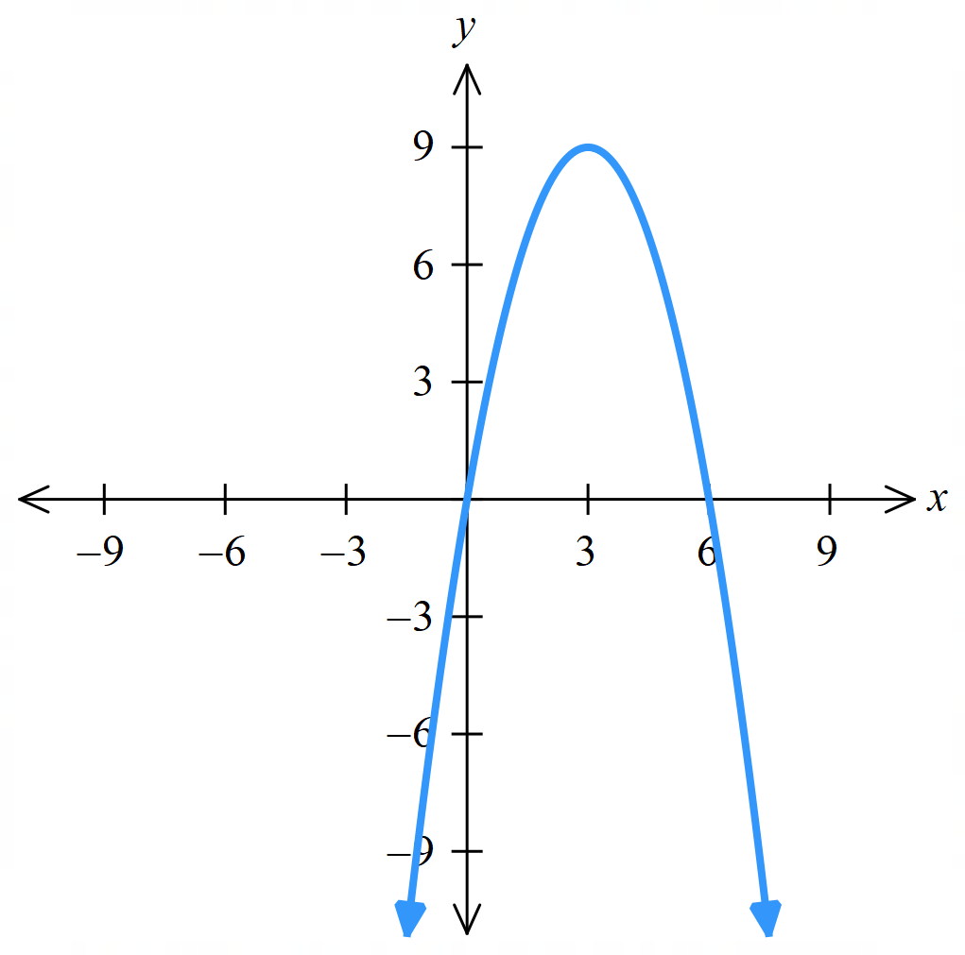  What is the significance of what you have just found?  When the gradient of the tangent is 0, it is the ……………… ……………… of a parabola.

- Practice
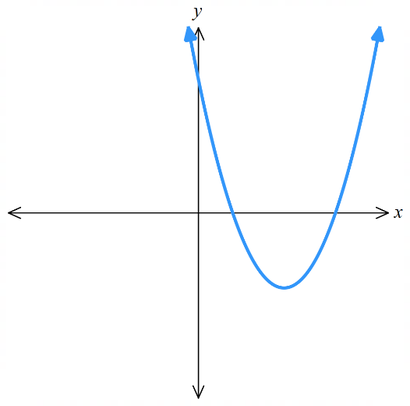
Find the point on the graph where $f\left(x\right)=x^{2}-5x+4$ has tangent of:
- Gradient $-3$
- Angle of inclination $45°$

$$a) \left(1,0\right)$$
$$b) \left(3,-2\right)$$
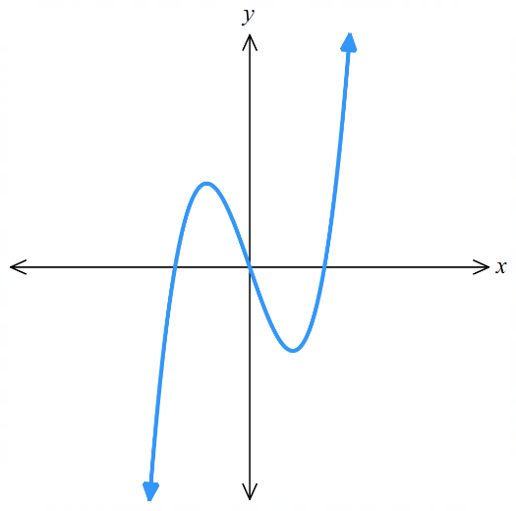
Find point(s) on $f\left(x\right)=x^{3}-3x$ where the tangent has gradient 0.

$$\left(-1,2\right) and \left(1,-2\right)$$

Foundation
- Given $f\left(x\right)=2x^{3}-3x+4$
  - Evaluate $f^{'}\left(1\right)$.
3
  - What does $f^{'}\left(1\right)$ represent?
The gradient of the tangent to the curve at $x=1$ is 3.
- Given $f\left(x\right)=x^{2}-x+5,$ evaluate:
- $f^{'}\left(3\right)$  5 | - $f^{'}\left(-2\right)$  – 5 | - $x$ when $f^{'}\left(x\right)=7$  $$x=4$$

- If $y=x^{3}-7$, evaluate:
- $\frac{dy}{dx}$ when $x=2$.  12 | - $x$ when $\frac{dy}{dx}$ $=12$.  $$±2$$

- Find the gradient of the tangent to $y=f(x)$ where $x=3$,
then find the angle of inclination of these tangents using $\tan{θ}=m$.
- $f(x)=x²-5x+2$  1, 45° | - $f(x)=x³-3x²-10x$  – 1, 135° | - $f(x)=2x²-18x$  – 6, 99°28’

- Find any points on these curves where the tangent has gradient $-1$.
- $y=$ $\frac{1}{x}$  $\left(1,1\right)$ and $\left(-1,-1\right)$ | - $y=$ $\frac{x^{-2}}{2}$  $$\left(1, \frac{1}{2}\right)$$

Development
- Find any points on these curves where the tangent has gradient $-1$.
- $y=-\sqrt{x}$  $$\left(\frac{1}{4},-\frac{1}{2} \right)$$ | - $y=\sqrt{x}$  none

- Find points on the graph of each function where the tangent has a gradient of 0.
- $f(x)=4+4x-x²$  (2, 8) | - $f(x)=x³-12x+24$  (2, 8) and $\left(-2,40\right)$
- $f(x)=3x+2$  none | - $f(x)=4x-x²$  (2, 4)
- $f(x)=x⁴-2x²$  (0,0), (1,– 1), and (– 1,– 1) | - $f(x)=x⁵+x$  none

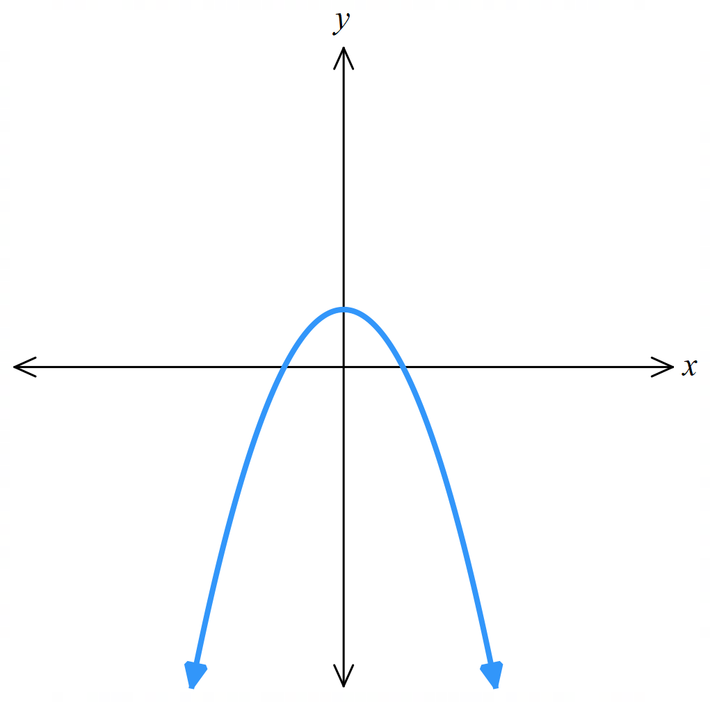
- Find, to the nearest minute, the angles of inclination of the tangents to the parabola $y=1-x^{2}$ at its $x$-intercepts.

$$y=\left(1-x\right)\left(1+x\right)$$
$x$-intercepts at $x=-1$ and $x=1$
$$f^{'}\left(x\right)=-2x$$
Let $f^{'}\left(-1\right)=2, f^{'}\left(1\right)=-2$
Use $\tan{θ}=m$ to find angle of inclination
63° 26’ at (– 1,0) and 116°34’ at (1,0)

- Find any points on each curve where the tangent has the given angle of inclination.
- $y=2\sqrt{x}, 30°$  $$\left(3,2\sqrt{3}\right)$$ | - $y=3 \sqrt[3]{x}, 45°$  $$\left(1,3\right) and \left(-1,-3\right)$$

- Consider the quadratic function $y=2x^{2}+9x-5$.
- Use $x=-$ $\frac{b}{2a}$ to find the $x$-coordinate of the turning point.  $$x=-\frac{b}{2a}=-\frac{9}{4}$$ | - By Finding $f^{'}\left(x\right)$ and letting it equal zero, find the $x$-coordinate of the turning point.  $$f^{'}\left(x\right)=4x+9$$  $$4x+9=0$$  $$x=-\frac{9}{4}$$

- Find any points on each curve where the tangent has the given angle of inclination.
- $y =\frac{x^{3}}{3} - 7, 45°$  $$\left(1,-\frac{20}{3}\right), \left(-1, -\frac{22}{3}\right)$$ | - $y = x^{2}+\frac{x^{3}}{3}, 135°$  $$\left(-1, \frac{2}{3}\right)$$ | - $y = x² + 1, 120°$  $$\left(-\frac{\sqrt{3}}{2},\frac{7}{4}\right)$$

- Find points on each graph where the tangent has gradient – 1.
- $y=x^{4}-5x$  $$\left(1,-4\right)$$ | - $y=x^{3}-4x$  $$\left(1,-3\right), \left(-1,3\right)$$ | - $y=x^{3}-4$  none
- In each function, first divide through by the denominator, then differentiate.
Factor the derivative and state any values of $x$ where the tangent is horizontal.
- $y=$ $\frac{3x^{4}-9x^{2}}{x}$  $$\frac{dy}{dx}=9\left(x-1\right)\left(x+1\right)$$  Tangent horizontal at $x=1$ or $x=-1$ | - $y=$ $\frac{5x^{6}+3x^{5}}{3x^{3}}$  $$\frac{dy}{dx}=x\left(5x+2\right)$$  $$x=0 or-\frac{2}{5}$$

- Find the derivative of the cubic $f(x)=x³+ax+b$, and hence find the $x$-coordinates of the points where the tangent is horizontal. For what values of $a$ and $b$ do such points exist?

$$f^{'}\left(x\right)=3x^{2}+a$$
Let $f^{'}\left(x\right)=0$
$$x=±\sqrt{-\frac{a}{3}}$$
Horizontal tangents exist when $a≤0$; there is no restriction on $b$.

  - Sketch the graph of $y=x^{2}-x$, labelling both $x$-intercepts.
  - Find the gradients of the tangents drawn from the $x$-intercepts.
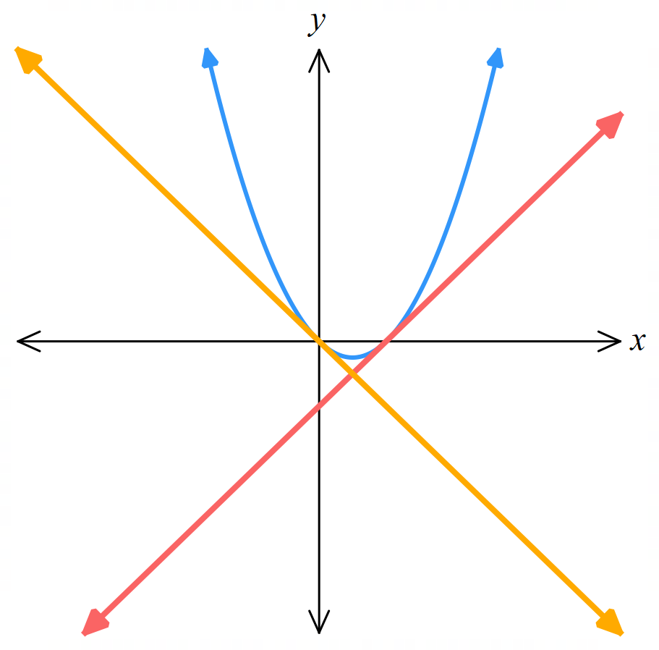
  - What do you notice about the gradients from part b? Explain this result.

Gradients of the tangents at the $x$-intercepts are $±1$.
The gradients have opposite signs because the parabola is symmetrical about its axis.

Mastery
- Find the derivative of $f(x)=x²-ax$.

$$f^{'}\left(x\right)=2x-a$$
Find the value of $a$ when:
  - the tangent at the origin has gradient $7$,

– 7
  - $y = f(x)$ has a horizontal tangent at $x = 3$,

6
  - the tangent at the point where $x = 1$ has an angle of inclination of 45°,

1
  - the tangent at the non-zero $x$-intercept has gradient 5,

5
  - the tangent at the vertex has $y$-intercept $-9$.

6 or – 6
- Use DESMOS to visualise your answers.

Equation of the Tangent and Normal

- Review
- Recall the definition of the tangent.
A tangent is a s………… l…………… that just t………… a curve at a particular point.
Identify which of the following are tangents at $x=a$.
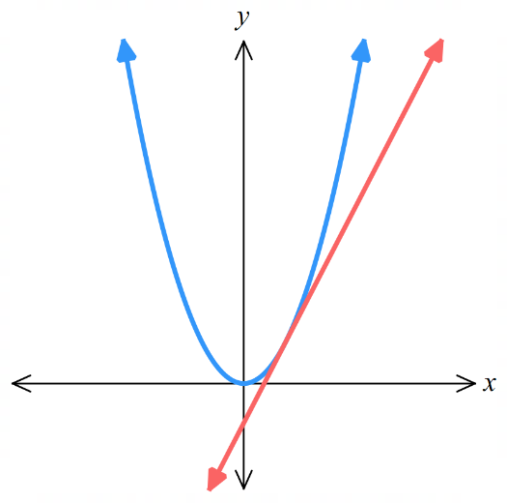
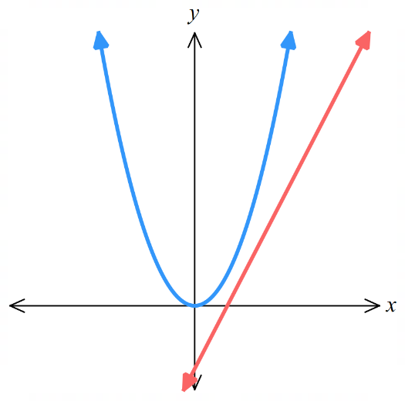
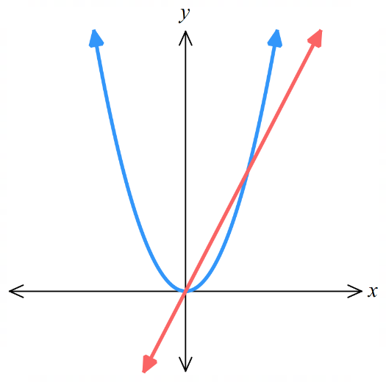
$$a$$
$$a$$
$$a$$

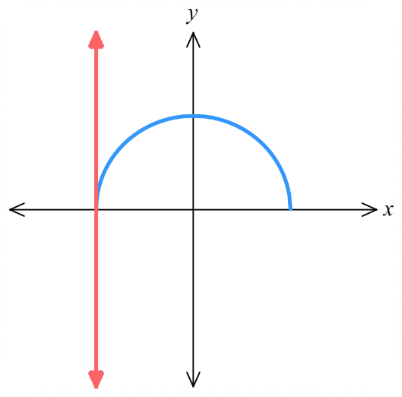
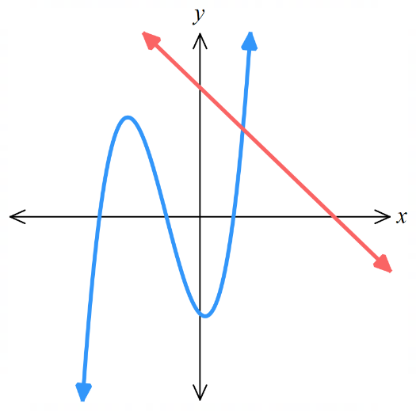
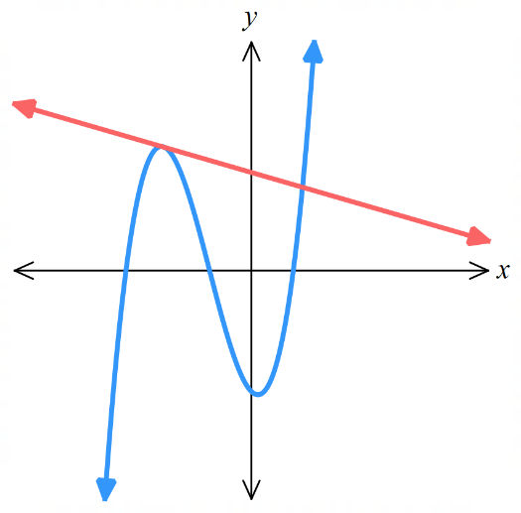
$$a$$
$$a$$
$$a$$

- Find points on a curve.
- $y=x^{2}+2x+3$. What is the point on the curve where $x=2$? | - $y=2x^{3}-3x^{2}$. What is the point on the curve where $x=-1$?

- Find the perpendicular gradient.
- $m=\frac{2}{3}$, $m_{⊥}=$ | - $m=-2$, $m_{⊥}=$ | - $m=\frac{1}{7}$, $m_{⊥}=$

- Find the equation of a line using point-gradient formula $y-y_{1}=m\left(x-x_{1}\right)$.
Answer in general form.
- Find the line with gradient 3, passing through (1,4) | - Find the line with gradient $-\frac{1}{5}$, passing through ($-2$,9)

- Finding the equation of the tangent
To find the equation of the tangent to a curve at $x=x_{1}$:
- Find point of tangency, if not already given, using $y_{1}=f\left(x_{1}\right)$.
- Differentiate to find the gradient function $f^{'}\left(x\right)$.
- Find gradient of the tangent at the given point $m=f^{'}\left(x_{1}\right)$.
- Find equation of the tangent using $\left(x_{1},y_{1}\right)$ and $y-y_{1}=m\left(x-x_{1}\right)$.

- Example Find the equation of the tangent to a curve
Find the equation of the tangent to $y=x^{2}-3x-1$ at $x=2.$
1. Point of tangency  $$y_{1}=f\left(2\right)=-3$$  2. Gradient function  $$f\left(x\right)=x^{2}-3x-1 \\ f^{'}\left(x\right)=2x-3$$ | 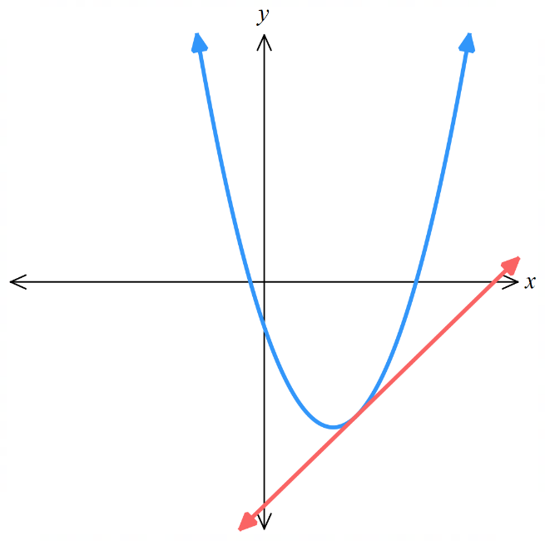  3. Gradient of tangent  $$m=f^{'}\left(2\right)=1$$  4. Equation of tangent  $$y-y_{1}=m\left(x-x_{1}\right) \\ y-(-3)=1\left(x-2\right) \\ y+3=x-2$$  $$y=x-5$$

- Practice
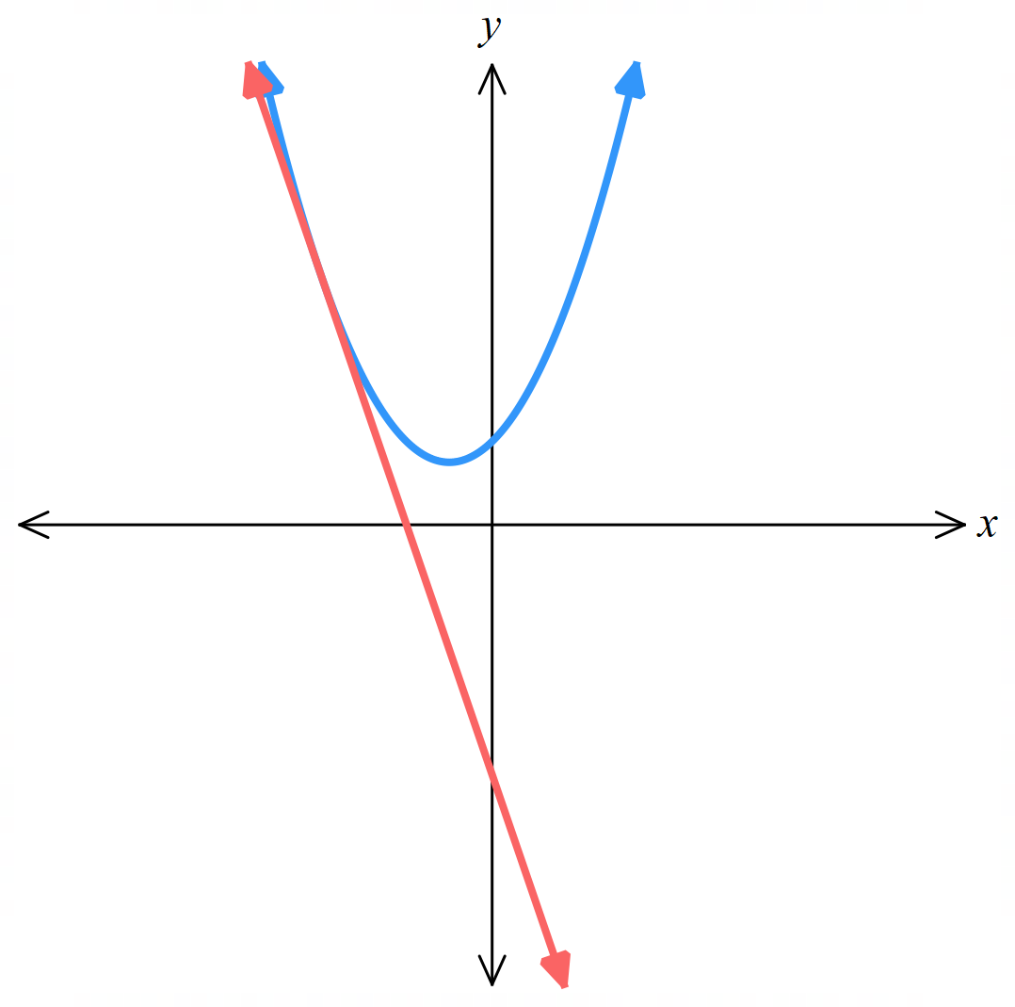
Find the equation of the tangent to $y=x^{2}+x+1$ at $P\left(-2,3\right)$.
1. Point of tangency 3. Gradient of tangent

2. Gradient function 4. Equation of tangent

$$y=-3x-3$$
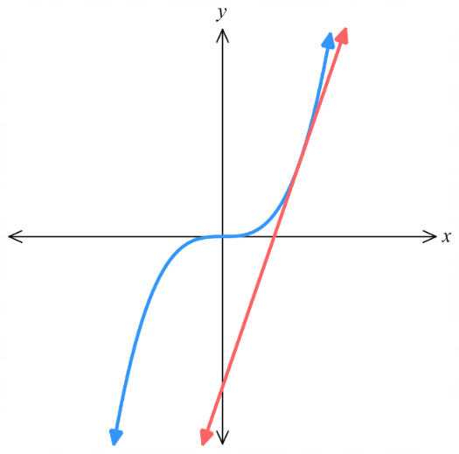
Find the equation of the tangent to $y=x^{3}$ at $x=2$.

$$y=12x-16$$

- The Normal to the Curve
The normal is the line perpendicular (at 90°) to the tangent at the point of contact.

- Identify the normal to a curve.
The dotted line shown is the tangent. Consider the solid line.
✖  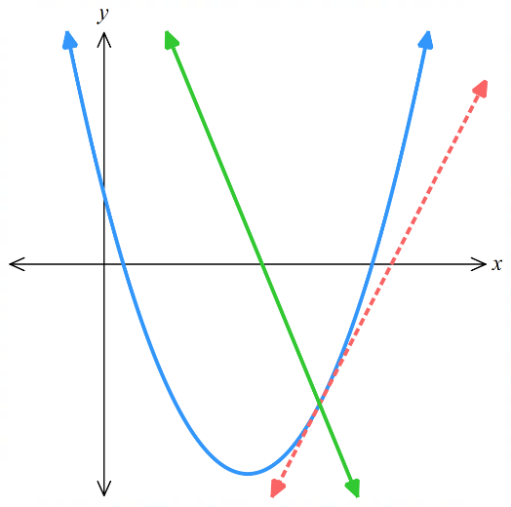 | ✔  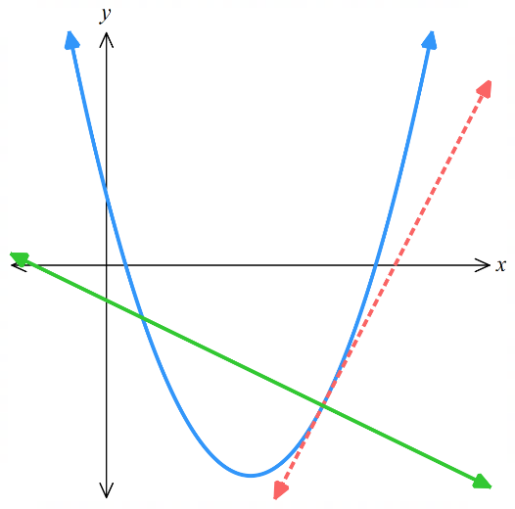 |  | ✔  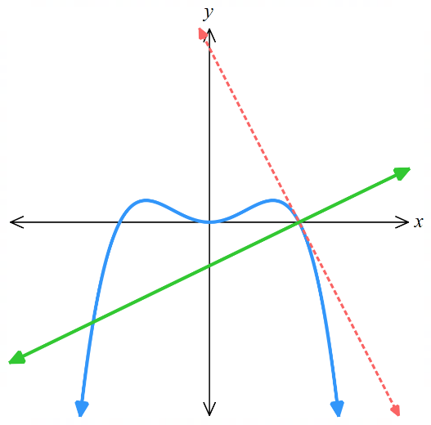 |  | ✖  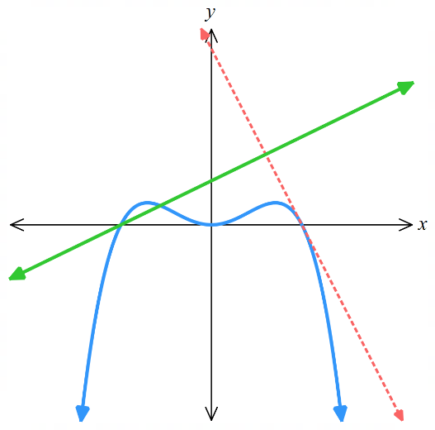
Draw the tangent and normal to these curves at $x=1$.
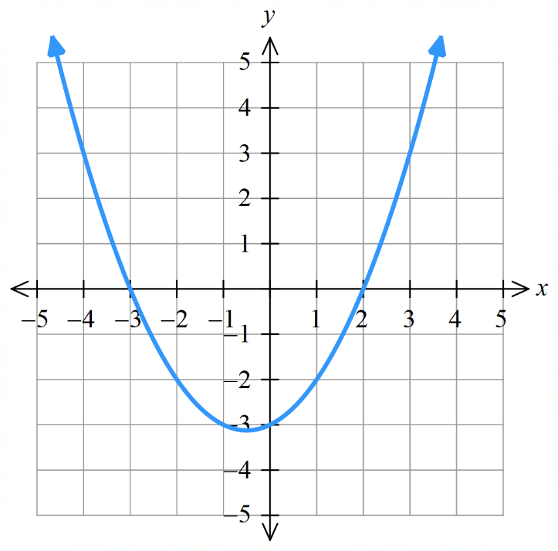 |  | 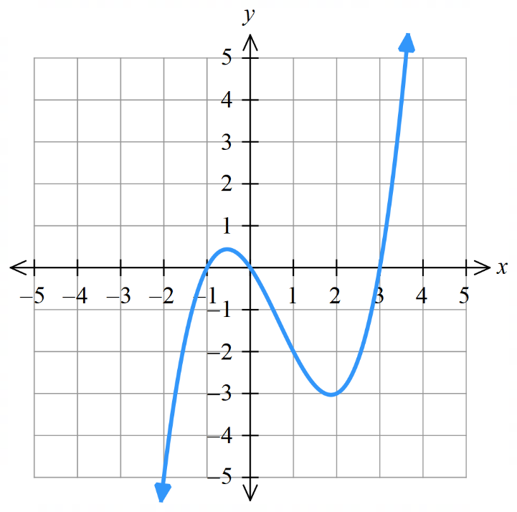 |  | 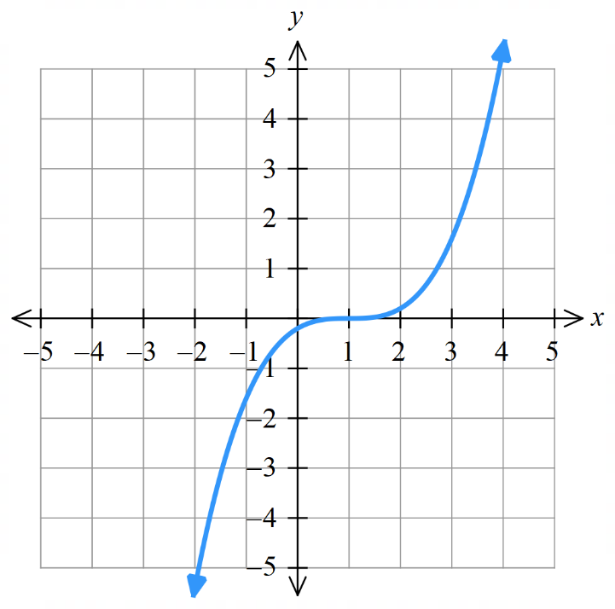

- Key Ideas
- The normal is the line ………………… to the tangent at the ………… of ……………….
- The line perpendicular to the tangent at the point of contact is called the …………………

- Finding the equation of the normal
To find the equation of the normal to a curve at $x=x_{1}$:
- Find point of tangency, if not already given, using $y_{1}=f\left(x_{1}\right)$.
- Differentiate to find the gradient function $f^{'}\left(x\right)$.
- Find gradient of the tangent at the given point $m=f^{'}\left(x_{1}\right)$.
- Find the gradient of the normal using $m_{⊥}=-$ $\frac{1}{m}$
- Find equation of the normal using $\left(x_{1},y_{1}\right)$ and $y-y_{1}=m_{⊥}\left(x-x_{1}\right)$.

- Example Find the equation of the normal to a curve.
Find the equation of the normal to $y=x^{2}-4x+1$ at $x=3$.
1. Point of tangency  $$y_{1}=f\left(3\right)=-2$$  2. Gradient function  $$f\left(x\right)=x^{2}-4x+1$$  $$f^{'}\left(x\right)=2x-4$$  3. Gradient of tangent  $$m=f^{'}\left(3\right)=2$$ | 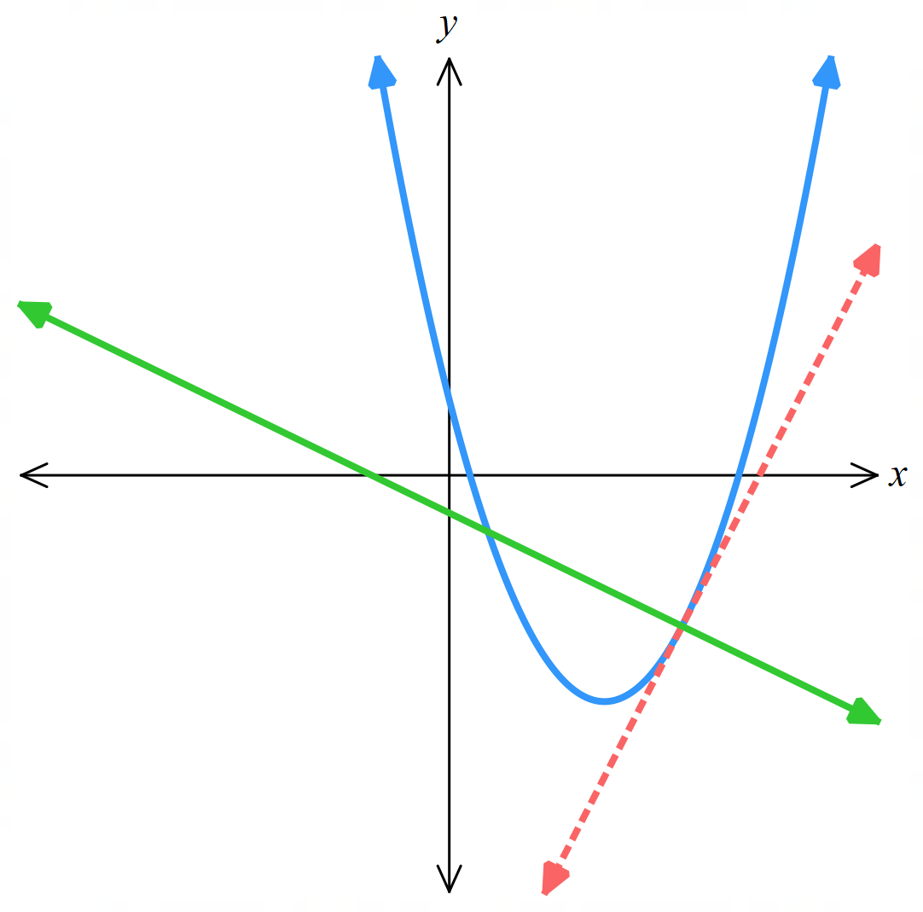  4. Gradient of normal  $$m_{⊥}=-\frac{1}{2}$$  5. Equation of normal  $$y-y_{1}=m_{⊥}\left(x-x_{1}\right) \\ y-\left(-2\right)=-\frac{1}{2}\left(x-3\right) \\ y+2=-\frac{x}{2}+\frac{3}{2}$$  $$y=-\frac{x}{2}-\frac{1}{2}$$

- Practice
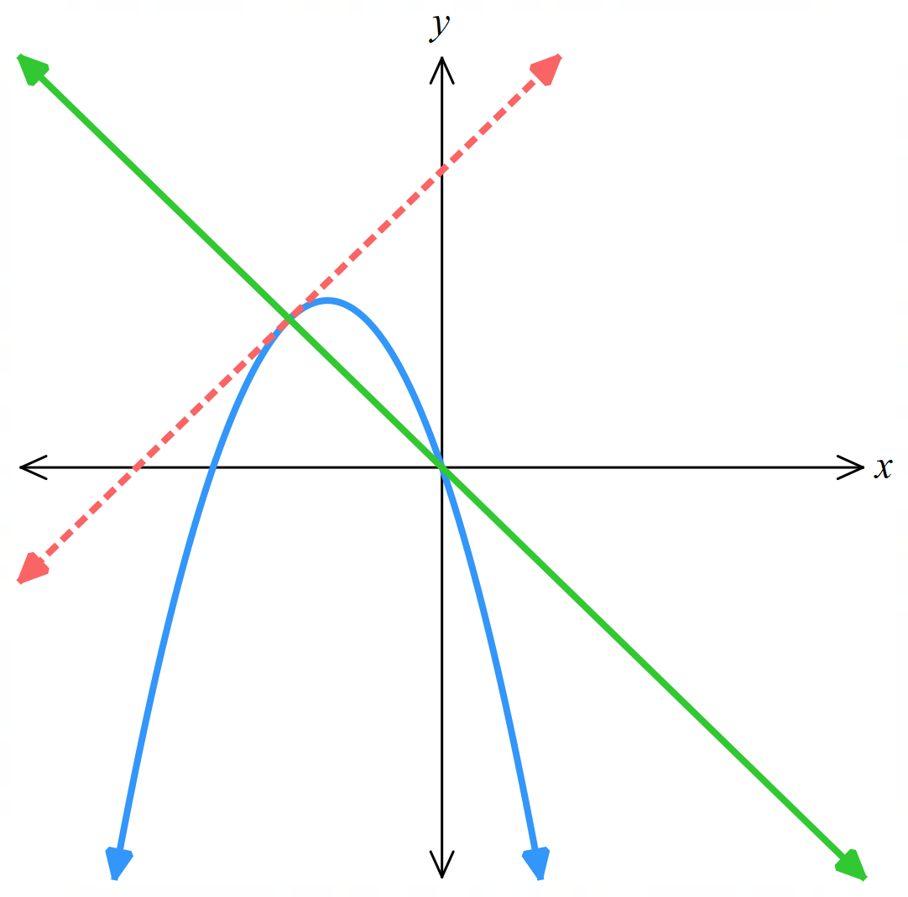
Find the equation of the normal to $y=-x^{2}-3x$ at $x=-2$.

$$y=-x$$

Foundation
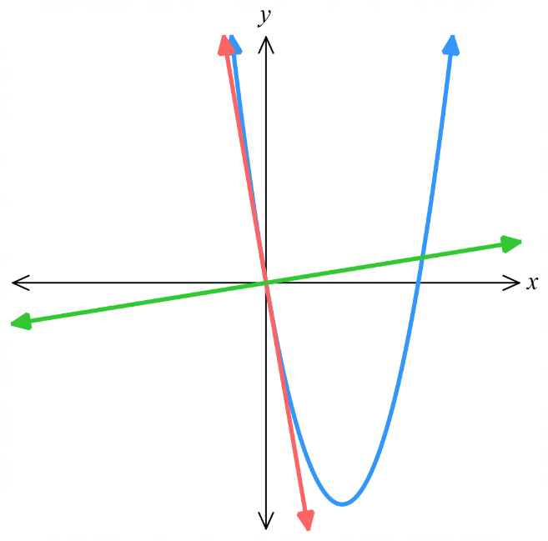
- Find the equation of the tangent and normal to each curve at the point indicated.
A sketch is provided for you to visualise your answer.
  - $f\left(x\right)=x^{2}-6x at O\left(0,0\right)$.
$f^{'}\left(x\right)=$
$m_{tangent}=f^{'}\left(0\right)=$ $m_{normal}=$

$y-y_{1}=m_{t}\left(x-x_{1}\right)$ $y-y_{1}=m_{n}\left(x-x_{1}\right)$

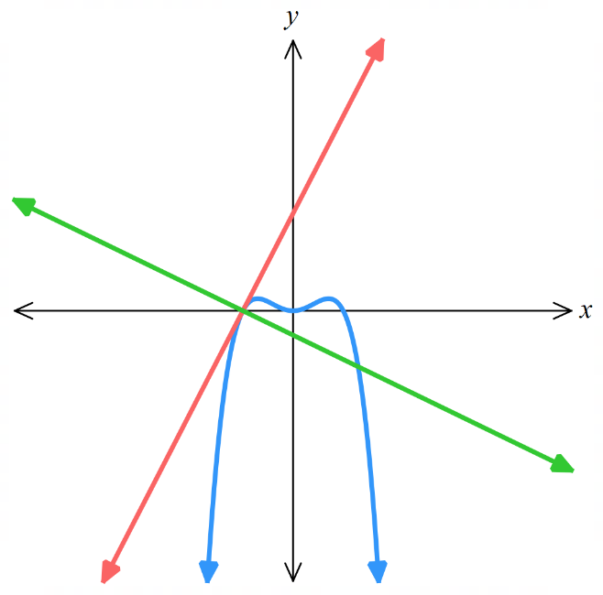
$$y=-6x, y=\frac{1}{6}x$$
  - $y=x^{2}-x^{4} at J\left(-1,0\right)$.

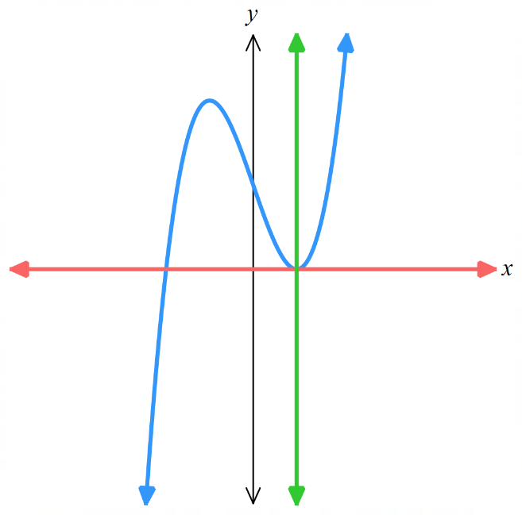
$$y=2x+2, y=-\frac{x}{2}-\frac{1}{2}$$
  - $y=x^{3}-3x+2 at P\left(1,0\right)$.

$$y=0, x=1$$

- Find the equation of the tangent to the curve, in general form:
- $y=3x^{3}+1$ where $x=2$  $$36x-y-47=0$$ | - $v=4t^{4}-7t^{3}-2$ where $t=2$  $$44t-v-82=0$$

Development
- Find the equation of the normal to the curve, in general form:
- $f\left(x\right)=x^{2}-5x-5$ where $x=-2$  $$x-9y+83=0$$ | - $y=x^{4}-2x^{3}+4x+1$ where $x=1$  $$x+2y-9=0$$

- Consider $f\left(x\right)= x^{2}- 6x.$
  - Find the gradient of the tangent and
normal at the point $A(a, a² - 6a)$ on the curve.

$$f^{'}\left(x\right)=2x-6$$
$$Gradient of tangent: f^{'}\left(a\right)=2a-6$$
$$Gradient of normal: \frac{-1}{2a-6}$$
  - Find the value of $a$ if:
- Use this DESMOS link to visualise your answers https://www.desmos.com/calculator/rp7iahb0vy
- the tangent has gradient 2.  4 | - the normal has gradient 4.  $$\frac{23}{8}$$
- the tangent has angle of inclination 135°.  $$\frac{5}{2}$$ | - the normal has angle of inclination 30°.  $$3-\frac{\sqrt{3}}{2}$$
- the tangent is parallel to  $2x - 3y + 4 = 0$.  $$\frac{10}{3}$$ | - the normal is parallel to  $2x - 3y + 4 = 0$.  $$\frac{9}{4}$$

Mastery
- Differentiate $y=x²+bx+c$.
$$y^{'}=2x+b$$
Hence find $b$ and $c$ given that:
  - the parabola passes through the origin, and the tangent there has gradient 7,

$$b=7, c=0$$
  - the parabola has $y$-intercept $-3$ and gradient $-2$ there,

$$b=-2, c=-3$$
  - the parabola is tangent to the $x$-axis at the point $(5, 0),$

$$b=-10, c=25$$
  - when $x=3$ the gradient is 5, and $x=2$ is a zero,

$$b=-1, c=-2$$
  - the parabola is tangent to $3x+y-5=0$ at the point $T(3, -4),$

$$b=-9, c=14$$
  - the line $3x+y-5=0$ is a normal at the point $T(3, -4)$.

$$b=-\frac{17}{3}, c=4$$

- Use DESMOS to visualise your answers. https://www.desmos.com/calculator/3rgiizn745

Chain Rule

- Review
- Differentiate using the power rule.
- $y=1-5x$  $$\frac{dy}{dx}=$$ | - $u=-7x^{3}$  $$\frac{du}{dx}=$$ | - $y=\sqrt{u}$  $$\frac{dy}{du}=$$

- Work with $u$ substitution.
- Consider $y=3u^{5}$  substitute $u=(2x+1)$into the expression. | - Consider $y=35\sqrt[3]{u}$  substitute $u=(3x^{2}-8)$into the expression.
- Simplify $y={\left(3x^{2}+5\right)}^{5}$ by  letting $u=3x^{2}+5$. | - Simplify $y=3\sqrt{2x-5}$ by  letting $u=2x-5$.

- Inner and Outer Functions
- Consider $y={\left(5-6x\right)}^{5}$. Differentiating this would require a lengthy expansion.
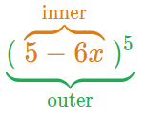
- Instead, we consider this a composite function $y\left(u\left(x\right)\right)$:
$$Let u\left(x\right)=1-6x \\ Then y\left(u\right)=u^{5}$$

- We call $u\left(x\right)$ the “inner” function and $y\left(u\right)$the “outer” function.
- The inner function is the one evaluated first; it is the function inside brackets.

- Interpret a composite function as an inner and outer function.
$$y={\left(2x-3\right)}^{5}$$  Inner: $u=2x-3$  Outer: $y=u^{5}$ | $$y=-9{\left(2x-3\right)}^{5}$$  Inner: $u=2x-3$  Outer: $y=-9u^{5}$ | $$y=\sqrt{7x^{2}-2x^{3}}$$  Inner: $u=7x^{2}-2x^{3}$  Outer: $y=\sqrt{u}$
Identify the inner and outer function for these composite functions.
- $y={\left(1-2x\right)}^{3}$  Inner:  Outer: | - $y={\left(1-2x\right)}^{-3}$  Inner:  Outer: | - $y=7{\left(1-2x\right)}^{3}$  Inner:  Outer:
- $y=\sqrt{3x+5}$  Inner:  Outer: | - $y=6\sqrt{3x+5}$  Inner:  Outer: | - $y=-13{\left(4x^{2}-x+3\right)}^{5}$  Inner:  Outer:

- Chain Rule
Chain rule: Multiply the derivative of the outer function by the derivative of the inner function.
For a composite function $y=g\left(f\left(x\right)\right)$, let $u=f\left(x\right)$ and $y=g\left(u\right),$ then:
$$\frac{dy}{dx}=\frac{dy}{du}×\frac{du}{dx}$$
- Identify the inner function $u\left(x\right)$ and find $\frac{du}{dx}$.
- Identify the outer function $y\left(u\right)$and find $\frac{dy}{du}$.
- Multiply the derivatives $\frac{dy}{dx}=\frac{dy}{du}×\frac{du}{dx}$.
- Substitute all $u$ terms back to $x$.

- When finding $\frac{du}{dx}$ and $\frac{dy}{du}$, write your working on the right-hand side to keep the main working area clear.

- Example Differentiate composite functions using the chain rule.
Differentiate $y={\left(1-6x\right)}^{5}$  $$3. \frac{dy}{dx}=\frac{dy}{du}×\frac{du}{dx} \\ =5u^{4}×-6 \\ =-30u^{4}$$  4. $=-30{\left(1-6x\right)}^{4}$ | 1. Let $u=1-6x$  $\frac{du}{dx}$ $=-6$  2. Let $y=u^{5}$  $\frac{dy}{du}$ $=5x^{4}$
Differentiate $y=3{\left(1-5x^{2}\right)}^{7}$  $$3. \frac{dy}{dx}=\frac{dy}{du}×\frac{du}{dx} \\ =21u^{6}×-10x \\ =-210xu^{6}$$  4. $=-210x{\left(1-5x^{2}\right)}^{6}$ | 1. Let $u=1-5x^{2}$  $\frac{du}{dx}$ $=-10x$  2. Let $y={3u}^{7}$  $\frac{dy}{du}$ $=21u^{6}$

- Practice
- Differentiate $y={\left(5x-9\right)}^{6}$  $$\frac{dy}{dx}=\frac{dy}{du}×\frac{du}{dx}$$  $$\frac{dy}{dx}=30(5x-9)⁵$$ | Let $u=5x-9$  $$\frac{du}{dx}=$$  Let $y=u^{6}$  $$\frac{dy}{du}=$$
- Differentiate $y={7\left(1-2x\right)}^{4}$  $$\frac{dy}{dx}=\frac{dy}{du}×\frac{du}{dx}$$  $$\frac{dy}{dx}=-56{\left(1-2x\right)}^{3}$$ | Let $u=1-2x$  $$\frac{du}{dx}=$$
- Differentiate $y={\left(x^{2}+x\right)}^{6}$  $$\frac{dy}{dx}=\frac{dy}{du}×\frac{du}{dx}$$  $$6{\left(x^{2}+x\right)}^{5}\left(2x+1\right)$$ | Let $u=$  $$\frac{du}{dx}=$$
- Differentiate $y=\sqrt{3x+5}$  $$\frac{dy}{dx}=\frac{dy}{du}×\frac{du}{dx}$$  $$\frac{dy}{dx}=\frac{3}{2\sqrt{3x+5}}$$ | Let $u=$  $$\frac{du}{dx}=$$

- Key Ideas
- We use the chain rule to differentiate ………………… functions.
- The chain rule is: Multiply the derivative of the …………… function by the derivative of the ……………… function.
- Using Leibniz notation, this is: $\frac{dy}{dx}=$ ……… $×$ ………

General Power Rule

- General Power Rule
We shortcut chain rule for a function raised to a power ${\left(f\left(x\right)\right)}^{n}$using the general power rule.
$$\frac{d}{dx}\left(f{\left(x\right)}^{n}\right)=nf^{'}\left(x\right) {\left[f\left(x\right)\right]}^{n-1}$$
- Multiply by the power.
- Reduce the power by 1.
- Multiply by the derivative of the inner function.
This is the same as chain rule:
Multiply the derivative of the outer function by the derivative of the inner function.

- Example Differentiate using the general power rule.
$$y={\left(5x^{4}+2\right)}^{10}$$  $$y^{'}=10{\left(5x^{4}+2\right)}^{9}×20x^{3}$$  $$=200x^{3}{\left(5x^{4}+2\right)}^{9}$$ | $$y=-3{\left(x^{5}+7x\right)}^{9}$$  $$y^{'}=-27{\left(x^{5}+7x\right)}^{8}\left(5x^{4}+7\right)$$

- Practice
Differentiate:
- $y={\left(5x^{3}-4\right)}^{8}$  $$y'=120x²(5x³ - 4)⁷$$ | - $y=2{\left(5x^{3}-4\right)}^{8}$  $$y^{'}=240x²(5x³ - 4)⁷$$
- $y={\left(5x^{3}-4x^{2}+2x\right)}^{8}$  $$y^{'}=8(15x² - 8x + 2)(5x³ - 4x² + 2x)⁷$$ | - $y={\left(4x-9x^{7}\right)}^{3}$  $$y^{'}=3(4 - 63x⁶)(4x - 9x⁷)²$$
- Example Differentiate using the general power rule (surds and fractions)
$$y=7\sqrt{4x^{3}+5x}$$  $$y=7{\left(4x^{3}+5x\right)}^{\frac{1}{2}}$$  $$y^{'}=\frac{7}{2}{\left(4x^{3}+5x\right)}^{-\frac{1}{2}}×\left(12x^{2}+5\right)$$  $$=\frac{7\left(12x^{2}+5\right)}{2\sqrt{4x^{3}+5x}}$$ | $$y=\frac{7}{4x^{3}+5x}$$  $$y=7{\left(4x^{3}+5x\right)}^{-1}$$  $$y^{'}=-7{\left(4x^{3}+5x\right)}^{-2}×\left(12x^{2}+5\right)$$  $$=\frac{-7(12x^{2}+5)}{{\left(4x^{3}+5x\right)}^{2}}$$

- Practice
Differentiate:
- $y=\sqrt{5x-9}$  $$y^{'}=\frac{5}{2\sqrt{5x - 9}}$$ | - $y=\sqrt{5x^{2}-9}$  $$y^{'}=\frac{5x}{\sqrt{5x^{2}- 9}}$$
- $y=\sqrt{9-5x^{2}}$  $$y=-\frac{5x}{\sqrt{9 - 5x^{2}}}$$ | - $y=3\sqrt{8-7x}$  $$y^{'}=-\frac{21}{2\sqrt{8 - 7x}}$$
- $y=$ $\frac{1}{x^{2}+3}$  $$y^{'}=-\frac{2x}{{\left(x^{2}+ 3\right)}^{2}}$$ | - $y=$ $\frac{7}{x^{2}+3}$  $$y^{'}=-\frac{14x}{{\left(x^{2}+ 3\right)}^{2}}$$

- Key Ideas
- When we have a function of the form $y=$ ………, we can shortcut the chain rule by multiplying by the power, reducing the ………… by ……, then multiplying by the …………… of the …………… function.

Foundation
- Use the chain rule to differentiate these functions.
Set 1 | Set 2 | Set 3
- $y={\left(2x+1\right)}^{3}$  $$6(2x+1)²$$ | - $y={\left(3x+2\right)}^{2}$  $$6\left(3x+2\right)$$ | - $y={\left(2x+1\right)}^{4}$  $$8{\left(2x+1\right)}^{3}$$
- $y={\left(3x+1\right)}^{3}$  $$9(3x+1)²$$ | - $y={\left(3x+2\right)}^{3}$  $$9{\left(3x+2\right)}^{2}$$ | - $y={\left(2x+3\right)}^{4}$  $$8{\left(2x+3\right)}^{3}$$
- $y={\left(4x+1\right)}^{3}$  $$12(4x+1)²$$ | - $y={\left(3x+2\right)}^{4}$  $$12{\left(3x+2\right)}^{3}$$ | - $y={\left(2x+5\right)}^{4}$  $$8{\left(2x+5\right)}^{3}$$
- $y={\left(5x+1\right)}^{3}$  $$15(5x+1)²$$ | - $y={\left(3x+2\right)}^{5}$  $$15{\left(3x+2\right)}^{4}$$ | - $y={\left(2x-5\right)}^{4}$  $$8{\left(2x-5\right)}^{3}$$
- $y={\left(\frac{x}{5}+1\right)}^{3}$  $$\frac{3}{5}{\left(\frac{x}{5}+1\right)}^{2}$$ | - $y={\left(3x+2\right)}^{-5}$  $$-15{\left(3x+2\right)}^{-6}$$ | - $y={\left(2x-5\right)}^{4}+3$  $$8{\left(2x-5\right)}^{3}$$
Set 4 | Set 5 | Set 6
- $y={\left(2x+1\right)}^{3}$  $$6(2x+1)²$$ | - $y={\left(x^{2}+1\right)}^{4}$  $$8x(x²+1)³$$ | - $y={\left(x^{2}+3\right)}^{5}$  $$10x(x²+3)⁴$$
- $y={2\left(2x+1\right)}^{3}$  $$12(2x+1)²$$ | - $y={\left(x^{2}+5\right)}^{4}$  $$8x(x²+5)³$$ | - $y={\left(7x^{2}+3x\right)}^{5}$  $$5(14x+3)(7x²+3x)⁴$$
- $y={3\left(2x+1\right)}^{3}$  $$18(2x+1)²$$ | - $y={\left(x^{2}-5\right)}^{4}$  $$8x(x^{2}-5)³$$ | - $y={\left(7x^{2}-3x\right)}^{5}$  $$5(14x-3)(7x²-3x)⁴$$
- $y={-3\left(2x+1\right)}^{3}$  $$-18(2x+1)²$$ | - $y={\left(7x^{2}-5\right)}^{4}$  $$56x(7x²-5)³$$ | - $y={\left(7x^{2}-3x\right)}^{5}+11$  $$5(14x-3)(7x²-3x)⁴$$
- $y=$ $\frac{{\left(2x+1\right)}^{3}}{4}$  $$\frac{3}{2}{\left(2x+1\right)}^{2}$$ | - $y={\left(7x^{3}-5\right)}^{4}$  $$84x^{2}{\left(7x^{3}-5\right)}^{3}$$ | - $y={\left(7x^{2}-3x\right)}^{5}+11x$  $$5(14x-3)(7x²-3x)⁴ + 11$$

- Differentiate $y={\left(x-3\right)}^{2}+12$ by:
- Expanding the RHS and differentiating each term.  $$y=x^{2}-6x+21$$  $$\frac{dy}{dx}=2x-6$$ | - By treating the expression as two terms and using chain rule to differentiate the first term.  $$\frac{dy}{dx}=2\left(x-3\right)$$  Which is the same as part a
- Differentiate.
- $y={\left(3x+7\right)}^{4}$  $$\frac{dy}{dx}=4(3x+7)³(3)$$  $$=12(3x+7)³$$ | - $y={\left(5-4x\right)}^{7}$  $$\frac{dy}{dx}=7(5-4x)⁶(-4)$$  $$=-28(5-4x)⁶$$ | - $y={\left(x^{2}+1\right)}^{12}$  $$\frac{dy}{dx}=12(x²+1)¹¹(2x)$$  $$=24x(x²+1)¹¹$$
- $8{\left(7-x^{2}\right)}^{4}$  $$\frac{dy}{dx}=8(4)(7-x²)³(-2x)$$  $$=-64x(7-x²)³$$ | - $y={\left(x^{2}+4x+1\right)}^{9}$  $$\frac{dy}{dx}=9(x²+4x+1)⁸(2x+4)$$  $$=9(2x+4)(x²+4x+1)⁸$$ | - $y=-3{\left(x^{3}+x+1\right)}^{6}$  $$\frac{dy}{dx}=-3(6)(x³+x+1)⁵(3x²+1)$$  $$=-18(3x²+1)(x³+x+1)⁵$$
- $y={\left(5x-7\right)}^{5}$  $$\frac{dy}{dx}=5(5x-7)⁴(5)$$  $$=25(5x-7)⁴$$ | - $y={\left(7x+3\right)}^{7}$  $$\frac{dy}{dx}=7(7x+3)⁶(7)$$  $$=49(7x+3)⁶$$ | - $y=9{\left(5x+3\right)}^{4}$  $$\frac{dy}{dx}=9(4)(5x+3)³(5)$$  $$=180(5x+3)³$$
- $y={\left(4-3x\right)}^{7}$  $$\frac{dy}{dx}=7(4-3x)⁶(-3)$$  $$=-21(4-3x)⁶$$ | - $y=6{\left(\frac{x}{2}-1\right)}^{4}$  $$\frac{dy}{dx}=6\left(4\right){\left(\frac{x}{2}-1\right)}^{3}\left(\frac{1}{2}\right)$$  $$=12{\left(\frac{x}{2}-1\right)}^{3}$$ | - $y={\frac{2}{3}\left(5-\frac{x}{3}\right)}^{4}$  $$\frac{dy}{dx}=\left(\frac{2}{3}\right)\left(4\right){\left(5-\frac{x}{3}\right)}^{3}\left(-\frac{1}{3}\right)$$  $$=-\frac{8}{9}{\left(5-\frac{x}{3}\right)}^{3}$$

- Find the $x$-coordinates of any points on $y={\left(4x-7\right)}^{3}$ where the tangent is:
  - Parallel to $y=108x+7$
  - Perpendicular to $x+12y+6=0$

$$\frac{dy}{dx} = 3(4x - 7)²(4) = 12(4x - 7)²$$
a) 12(4x - 7)² = 108; $x=$ $\frac{5}{2}$ or 1
b) 12(4x - 7)² = 12; $x=2$or $\frac{3}{2}$

- Find the equations of the tangent and normal to each curve at the point where $x=1$.
- $y={\left(5x-4\right)}^{4}$  $$Tangent:y=20x-19$$  $$Normal:y=-\frac{x}{20}+\frac{21}{20}$$ | - $y={\left(x^{2}+1\right)}^{3}$  $$Tangent:y=24x-16$$  $$Normal:y=-\frac{x}{24}+\frac{193}{24}$$

Development
- Use the chain rule to differentiate these functions.
Set 1 | Set 2 | Set 3
- $y={\left(x^{2}+x+1\right)}^{5}$  $$5(2x+1)(x²+x+1)⁴$$ | - $y={\left(3x+1\right)}^{\frac{1}{2}}$  $$\frac{3}{2\sqrt{3x+1}}$$ | - $y={\left(7x+3\right)}^{-1}$  $$-\frac{7}{{\left(7x+3\right)}^{2}}$$
- $y={\left(x^{2}+2x+1\right)}^{5}$  $$10(x+1)(x²+2x+1)⁴$$ | - $y=\sqrt{3x+1}$  $$\frac{3}{2\sqrt{3x+1}}$$ | - $y=$ $\frac{1}{7x+3}$  $$-\frac{7}{{\left(7x+3\right)}^{2}}$$
- $y={\left(3x^{2}+2x+1\right)}^{5}$  $$10(3x+1)(3x²+2x+1)⁴$$ | - $y=\sqrt{3x^{2}+x}$  $$\frac{6x+1}{2\sqrt{3x^{2}+x}}$$ | - $y=$ $\frac{5}{7x+3}$  $$-\frac{35}{{\left(7x+3\right)}^{2}}$$
- $y={\left(3x^{2}-2x+1\right)}^{5}$  $$10(3x-1)(3x²-2x+1)⁴$$ | - $y=5\sqrt{3x+1}$  $$\frac{15}{2\sqrt{3x+1}}$$ | - $y=$ $\frac{1}{{\left(7x+3\right)}^{2}}$  $$-\frac{14}{{\left(7x+3\right)}^{3}}$$
- $y={6\left(3x^{2}-2x+1\right)}^{5}$  $$60(3x-1)(3x²-2x+1)⁴$$ | - $y=\sqrt{5x+1}$  $$\frac{5}{2\sqrt{5x+1}}$$ | - $y=$ $\frac{1}{\sqrt{7x+3}}$  $$-\frac{7}{2\sqrt{{\left(7x+3\right)}^{3}}}$$
- $y={\left(3x^{4}-2x^{3}-x^{2}\right)}^{5}$  $$10x(6x²-3x-1)(3x⁴-2x³-x²)⁴$$ | - $y=\sqrt[3]{5x+1}$  $$\frac{5}{3 \sqrt[3]{{\left(5x+1\right)}^{2}}}$$ | - $y=$ $\frac{1}{7x^{2}+3}$  $$-\frac{14x}{{\left(7x^{2}+3\right)}^{2}}$$
- Differentiate each function and find any points where the tangent is horizontal.
- $y=4+{\left(x-5\right)}^{6}$  $$\frac{dy}{dx}=6(x-5)⁵$$  $$(5,4)$$ | - $y=24-7{\left(x-5\right)}^{2}$  $$\frac{dy}{dx}=-14(x-5)$$  $$(5,24)$$ | - $y=a{\left(x-h\right)}^{2}+k$  $$\frac{dy}{dx}=2a(x-h)$$  $$\left(h,k\right)$$
- $y={\left(x^{2}-1\right)}^{3}$  $$\frac{dy}{dx}=6x(x²-1)²$$  $$(0,-1),(1,0),(-1,0)$$ | - $y={\left(x^{2}-4x\right)}^{4}$  $$\frac{dy}{dx}=4(2x-4)(x²-4x)³$$  $$(0,0),(2,256),(4,0)$$ | - $y={\left(2x+x^{2}\right)}^{5}$  $$\frac{dy}{dx}=10(1+x)(2x+x²)⁴$$  $$(-2,0),(-1,-1),(0,0)$$

- Differentiate, leave results in index form.
- $y={\left(7x-5\right)}^{-6}$  $$\frac{dy}{dx}=-6{\left(7x-5\right)}^{-7}\left(7\right)$$  $$=-42(7x-5)⁻⁷$$ | - $y=\frac{1}{3+5x}$  $$y={\left(3+5x\right)}^{-1}$$  $$\frac{dy}{dx}=-1{\left(3+5x\right)}^{-2}\left(5\right)$$  $$=-5{\left(3+5x\right)}^{-2}$$
- $y=\frac{4}{2x-1}$  $$y=4{\left(2x-1\right)}^{-1}$$  $$\frac{dy}{dx}=4\left(-1\right){\left(2x-1\right)}^{-2}\left(2\right)$$  $$=-8{\left(2x-1\right)}^{-2}$$ | - $y=\frac{3}{4{\left(5x+6\right)}^{7}}$  $$y=\frac{3}{4}{\left(5x+6\right)}^{-7}$$  $$\frac{dy}{dx}=\frac{3}{4}\left(-7\right){\left(5x+6\right)}^{-8}\left(5\right)$$  $$=-\frac{105}{4}{\left(5x+6\right)}^{-8}$$

Mastery
- Differentiate by first writing in index form. Leave your results in index form.
- $y={\left(7+2x\right)}^{\frac{4}{3}}$  $$\frac{dy}{dx}=\frac{4}{3}{\left(7 + 2x\right)}^{\frac{1}{3}}\left(2\right)$$  $$=\frac{8}{3}{\left(7 + 2x\right)}^{\frac{1}{3}}$$ | - $y=\sqrt{x+4}$  $$\frac{dy}{dx} =\frac{1}{2}{\left(x + 4\right)}^{-\frac{1}{2}}\left(1\right)$$  $$=\frac{1}{2}{\left(x + 4\right)}^{-\frac{1}{2}}$$
- $y=\sqrt{5-3x}$  $$\frac{dy}{dx} =\frac{1}{2}{\left(5 - 3x\right)}^{-\frac{1}{2}}(-3)$$  $$= -\frac{3}{2}{\left(5 - 3x\right)}^{-\frac{1}{2}}$$ | - $y=4{\left(2-5x\right)}^{-\frac{9}{4}}$  $$\frac{dy}{dx} = 4\left(-\frac{9}{4}\right){\left(2 - 5x\right)}^{-\frac{13}{4}}\left(-5\right)$$  $$= 45{\left(2 - 5x\right)}^{-\frac{13}{4}}$$

- Find the equations of the tangent and normal to each curve at the point $T\left(4,2\right).$
- $y=\sqrt{x}$  $$Tangent:y=\frac{x}{4}+1$$  $$Normal:y=-4x+18$$ | - $y=\sqrt{8-x}$  $$Tangent:y=-\frac{x}{4}+3$$  $$Normal:y=4x-14$$

- Find the equations of the tangent and normal to each curve at the point $x=1.$
- $y=$ $\frac{3}{4x-1}$  $$Tangent: y = -\frac{4}{3}x +\frac{7}{3}$$  $$Normal: y =\frac{3}{4}x +\frac{1}{4}$$ | - $y=$ $\frac{3}{{\left(x-2\right)}^{3}}$  $$Tangent: y = -9x + 6$$  $$Normal: y =\frac{1}{9}x -\frac{28}{9}$$

- Differentiate and find coordinates of any points where the tangent is horizontal.
- $y=$ $\frac{1}{1+x^{2}}$  $$y={\left(1+x^{2}\right)}^{-1}$$  $$\frac{dy}{dx} = -1(1 + x²)⁻²(2x) = -2x(1 + x²)⁻²$$  $$=-\frac{2x}{{\left(1+x^{2}\right)}^{2}}$$  $$\left(0,1\right)$$ | - $y=$ $-$ $\frac{3}{x^{4}-2x^{2}-1}$  $$y=-3{\left(x^{4}-2x^{2}-1\right)}^{-1}$$  $$\frac{dy}{dx}=3(-1)(x⁴ - 2x² - 1)⁻²(4x³ - 4x)$$  $$=-12x(x² - 1)(x⁴ - 2x² - 1)⁻²$$  $$=\frac{12x\left(x^{2}-1\right)}{{\left(x^{4}-2x^{2}-1\right)}^{2}}$$  $$\left(0,3\right), \left(1, \frac{3}{2}\right), \left(-1, \frac{3}{2}\right)$$
- Find the value of $a$ if:
- $y={\left(x-a\right)}^{3}$ has a tangent with gradient 12 when $x=6$.  $$y^{'}=3{\left(x-a\right)}^{2}\left(1\right)=3{\left(x-a\right)}^{2}$$  $$3(6-a)²=12$$  $$a=4 or a=8$$ | - $y={\left(5x+a\right)}^{4}$ has a tangent with gradient $-160$ when $x=3$.  $$y^{'}=4{\left(5x+a\right)}^{3}\left(5\right)=20{\left(5x+a\right)}^{3}$$  $$20(5(3)+a)³=-160$$  $$a=-17$$

- Find $a$, if the normal to $y=\sqrt{x+a}$at the point where $x=4$ has gradient $-6$.
$$y = \sqrt{x + a} = {\left(x + a\right)}^{\frac{1}{2}}$$
$$\frac{dy}{dx} =\frac{1}{2}{\left(x + a\right)}^{-\frac{1}{2}}\left(1\right)$$
$$=\frac{1}{2\sqrt{x + a}}$$
$$At x = 4:\frac{dy}{dx} =\frac{1}{2\sqrt{4 + a}}$$
$$Normal gradient = -\frac{1}{tangent gradient}$$
$$-6 = -1 ÷ \frac{1}{2\sqrt{4 + a}}$$
$$-6 = -2\sqrt{4 + a}$$
$$a = 5$$
- Use chain rule to differentiate, then find coordinates where the tangent is horizontal.
- $y=\sqrt{x^{2}-2x+5}$  $$\frac{dy}{dx}=\frac{1}{2}{\left(x^{2}- 2x + 5\right)}^{-\frac{1}{2}}(2x - 2)$$  $$= \left(x - 1\right){\left(x^{2}- 2x + 5\right)}^{-\frac{1}{2}}$$  $$=\frac{x-1}{\sqrt{x^{2}-2x+5}}$$  $$\left(1,2\right)$$ | - $y=\sqrt{x^{2}-2x}$  $$\frac{dy}{dx}=\frac{1}{2}{\left(x^{2}- 2x\right)}^{-\frac{1}{2}}(2x - 2)$$  $$= \left(x - 1\right){\left(x^{2}- 2x\right)}^{-\frac{1}{2}}$$  $$=\frac{x-1}{\sqrt{x^{2}-2x}}$$  No horizontal tangent as $x=1$ is not in domain.
- $y=7\sqrt{x^{2}+1}$  $$\frac{dy}{dx} = 7\left(\frac{1}{2}\right){\left(x^{2}+ 1\right)}^{-\frac{1}{2}}\left(2x\right)$$  $$= 7x{\left(x^{2}+ 1\right)}^{-\frac{1}{2}}$$  $$=\frac{7x}{\sqrt{x^{2}}+1}$$  $$\left(0,7\right)$$ | - $y=$ $\frac{1}{1+\sqrt{x}}$  $$\frac{dy}{dx} = -1{\left(1 + x^{\frac{1}{2}}\right)}^{-2}\left(\frac{1}{2}\right)x^{-\frac{1}{2}}$$  $$= -\frac{1}{2}x^{-\frac{1}{2}}{\left(1 + \sqrt{x}\right)}^{-2}$$  $$=\frac{-1}{2\sqrt{x}{\left(1+\sqrt{x}\right)}^{2}}$$  No horizontal tangent.

Product Rule

- Review
- Differentiate using general power rule.
- $y=5x^{3}$ | - $y=\sqrt{x}$ | - $y=$ $\frac{1}{x^{2}}$
- $y={\left(4x+1\right)}^{5}$ | - $y={\left(4x^{2}-3x\right)}^{3}$ | - $y=\sqrt{2x+1}$

- Factorise binomial common factors.
- $2x\left(x-3\right)+5\left(x-3\right)$ | - $2x{\left(x-3\right)}^{2}+5{\left(x-3\right)}^{3}$
- $2x^{2}\left(x-3\right)+5x\left(x-3\right)$ | - $2x^{2}{\left(x-3\right)}^{2}+5x{\left(x-3\right)}^{3}$

- Product Rule
For a product of two functions $y=uv$, we use the product rule.
$$\frac{dy}{dx}=v\frac{du}{dx}+u\frac{dv}{dx} \\ y^{'}=u^{'}v+uv'$$
- Identify $u$, then find $u'$.
- Identify $v$, then find $v'$.
- Differentiate using $y^{'}=u^{'}v+uv'$.

- Example Differentiate using product rule.
Differentiate $y=\left(4x^{3}-2\right)\left(3x^{2}-1\right)$  $$3. y^{'}=u^{'}v+uv^{'} \\ =12x^{2}\left(3x^{2}-1\right)+\left(4x^{3}-2\right)\left(6x\right) \\ =12x^{2}\left(3x^{2}-1\right)+6x\left(4x^{3}-2\right)$$ | 1. $u=4x^{3}-2$  $$u'=12x^{2}$$  2. $v=3x^{2}-1$  $$v'=6x$$

- Practice
Differentiate these functions.
- $y=(3-4x)(2x+19)$  $y^{'}=u^{'}v+uv^{'}$  $$y^{'}=-16x-70$$ | $$u=3-4x$$  $$u'=$$  $$v=2x+19$$  $v'=$
- $y=\left(2x^{5}-1\right)\left(x^{3}-3x+5\right)$  $$y^{'}=10x^{4}\left(x^{3}-3x+5\right)+\left(2x^{5}-1\right)\left(3x^{2}-3\right)$$ | $$u=$$  $$u'=$$  $$v=$$  $v'=$

- Product Rule involving Chain Rule
For a product of two functions $y=uv$, we use the product rule.
$$y^{'}=u^{'}v+uv'$$
The derivative of one factor may require the chain rule.
After applying the product rule, you might be able to factorise the expression.

- Example Differentiate using product rule and chain rule.
Differentiate $y=4x^{2}{\left(3x+1\right)}^{5}$  $$y^{'}=u^{'}v+uv^{'}$$  $$=8x{\left(3x+1\right)}^{5}+4x^{2}\left(15{\left(3x+1\right)}^{4}\right)$$  $$=8x{\left(3x+1\right)}^{5}+60x^{2}{\left(3x+1\right)}^{4}$$  $$=4x{\left(3x+1\right)}^{4}\left[2\left(3x+1\right)+15x\right]$$  $$=4x{\left(3x+1\right)}^{4}\left(21x+2\right)$$ | $$u=4x^{2}$$  $$u'=8x$$  $$v={\left(3x+1\right)}^{5}$$  $$v^{'}=5{\left(3x+1\right)}^{4}\left(3\right)$$  $=15{\left(3x+1\right)}^{4}$

- Practice
Differentiate
- $y=x{\left(x-10\right)}^{4}$  $$y^{'}=5{\left(x-10\right)}^{3}\left(x-2\right)$$ | $$u=x$$  $$u'=$$  $$v={\left(x-10\right)}^{4}$$  $v'=$
- $y=8x^{3}{\left(2x-5\right)}^{2}$

$$y'=40x^{2}\left(2x-5\right)\left(2x-3\right)$$

Foundation
- Differentiate each function by expanding and differentiating each term.
- $y=x^{3}\left(x-2\right)$  $$y^{'}=4x^{3}-6x^{2}$$ | - $y=\left(2x+1\right)\left(x-5\right)$  $$y^{'}=4x-9$$ | - $y=\left(x^{2}-3\right)\left(x^{2}+3\right)$  $$y^{'}=4x^{3}$$

- Differentiate each function using product rule.
- $y=x^{3}\left(x-2\right)$  $y^{'}=u^{'}v+uv^{'}$  $$y'=3x²(x-2)+x³(1)$$  $$=3x³-6x²+x³$$  $$=4x³-6x²$$ | $$u=x^{3}$$  $$u'=$$  $$u=x³, u'=3x²$$  $$v=x-2$$  $v'=$  $$v=x-2,v'=1$$
- $y=\left(2x+1\right)\left(x-5\right)$  $y^{'}=u^{'}v+uv^{'}$  $$y'=2(x-5)+(2x+1)(1)$$  $$=2x-10+2x+1$$  $$=4x-9$$ | $$u=2x+1$$  $$u'=$$  $$u=2x+1,u'=2$$  $$v=x-5$$  $v'=$  $$v=x-5,v'=1$$
- $y=\left(x^{2}-3\right)\left(x^{2}+3\right)$  $y^{'}=u^{'}v+uv^{'}$  $$y'=2x(x²+3)+(x²-3)(2x)$$  $$=2x³+6x+2x³-6x$$  $$=4x³$$ | $$u=$$  $$u'=$$  $$u=x²-3,u'=2x$$  $$v=$$  $v'=$  $$v=x²+3,v'=2x$$

- Differentiate using product rule, and state where the tangent is horizontal.
- $y=x(3-2x)⁵$  $$y^{'}=3(3-2x)⁴(1-4x)$$  $$x=\frac{3}{2}, \frac{1}{4}$$ | - $y=x³(x+1)⁴$  $$y^{'}=x²(x+1)³(7x+3),$$  $$x=0,-1,-\frac{3}{7}$$ | - $y=x⁵(1-x)⁷$  $$y^{'}=x⁴(1-x)⁶(5-12x),$$  $$x=0,1,\frac{5}{12}$$
- $y=(x-1)(x-2)³$  $$y^{'}=(x-2)²(4x-5)$$  $$x=2,\frac{5}{4}$$ | - $y=2(x+1)³(x+2)⁴$  $$y^{'}=2(x+1)²(x+2)³(7x+10)$$  $$x=-1,-2, -\frac{10}{7}$$ | - $y=(2x-3)⁴(2x+3)⁵$  $$y^{'}=6(2x-3)³(2x+3)⁴(6x-1)$$  $$x=\frac{3}{2},-\frac{3}{2},\frac{1}{6}$$

Development
- Find the tangents and normals to these curves at the indicated points.
- $y=x{\left(1-x\right)}^{6}$ at the origin.  $$y=x,$$  $$y=-x$$ | - $y={\left(2x-1\right)}^{3}{\left(x-2\right)}^{4}$ at $A\left(1,1\right)$  $$y=2x-1,$$  $$y=-\frac{x}{2}+\frac{3}{2}$$

- Differentiate each function using the product rule. One of the factors will require the chain rule.
Answer in fully factored form.
- $y=x{\left(x^{2}+1\right)}^{5}$  $$y^{'}={\left(x^{2}+1\right)}^{4}\left(11x^{2}+1\right)$$ | - $y=2πx^{3}{\left(1-x^{2}\right)}^{4}$  $$y^{'}=2πx^{2}{\left(1-x^{2}\right)}^{3}\left(3-11x^{2}\right)$$ | - $y=-2x{\left(x^{2}+x+1\right)}^{3}$  $$y^{'}=-2{\left(x^{2}+x+1\right)}^{2}\left(7x^{2}+4x+1\right)$$

- Differentiate $y={\left(x^{2}-10\right)}^{3}x^{4}$ using the chain rule and product rule.
Then find points on the curve where the tangent is horizontal.

$$y^{'}=10x^{3}{\left(x^{2}-10\right)}^{2}\left(x^{2}-4\right)$$
$$\left(0,0\right), \left(\sqrt{10},0\right), \left(-\sqrt{10},0\right),\left(2,-3456\right),\left(-2,-3456\right)$$
- Differentiate each function using the product rule.
Combine the terms using a common denominator and factor the numerator completely.
State the values of $x$ for which the derivative is zero.
- $y=6x\sqrt{x+1}$  $$y^{'}=\frac{3\left(3x+2\right)}{\sqrt{x+1}}$$  $$x=-\frac{2}{3}$$ | - $y=-4x\sqrt{1-2x}$  $$y^{'}=\frac{4\left(3x-1\right)}{\sqrt{1-2x}}$$  $$x=\frac{1}{3}$$ | - $y=10x^{2}\sqrt{2x-1}$  $$y^{'}=\frac{10x\left(5x-2\right)}{\sqrt{2x-1}}$$  $$x=0 and\frac{2}{5}$$  But neither of these are in the domain, so there are no values of $x$ where the derivative is zero

Quotient Rule

- Review
- Differentiate using product rule.
- $y=3x^{5}\left(4x-3\right)$ | - $y=\left(3-2x\right)\left(x^{2}-5x+3\right)$

- Expand and simplify expressions.
- $3(5x+2)-5(3x-1)$ | - $7(2x+1)-3(4x+2)$

Given the following, find an expression for $u^{'}v-uv^{'}$
- $u=2x+1$ $v=x^{2}u^{'}=2$ $v'=2x$ | - $u=2x+1$ $v=x+3u^{'}=2$ $v'=1$
- $u=x^{2}+3x$ $v=2x+1u^{'}=2x+3$ $v^{'}=2$ | - $u=x^{2}-3x$ $v=5-x^{3}u^{'}=2x-3$ $v^{'}=-3x^{2}$

- Quotient Rule
For a quotient of two functions $y=$ $\frac{u}{v}$, we use the quotient rule.
$$\frac{dy}{dx}=\frac{v\frac{du}{dx}-u\frac{dv}{dx}}{v^{2}} \\ y^{'}=\frac{u^{'}v-uv^{'}}{v^{2}}$$
- Identify $u$, then find $u'$.
- Identify $v$, then find $v'$.
- Differentiate using $y^{'}=$ $\frac{u^{'}v-uv^{'}}{v^{2}}$

- Example Differentiate using quotient rule.
Differentiate $y=$ $\frac{3x-1}{5x+2}$  $$3. y^{'}=\frac{u^{'}v-uv^{'}}{v^{2}} \\ =\frac{3\left(5x+2\right)-5\left(3x-1\right)}{{\left(5x+2\right)}^{2}} \\ =\frac{15x+6-15x+5}{{\left(5x+2\right)}^{2}} \\ =\frac{11}{{\left(5x+2\right)}^{2}}$$ | 1. $u=3x-1$  $$u'=3$$  2. $v=5x+2$  $$v'=5$$

- Practice
Differentiate
- $y=$ $\frac{8x+5}{7x-3}$  $y^{'}=$ $\frac{u^{'}v-uv^{'}}{v^{2}}$  $$y^{'}=-\frac{59}{{\left(7x-3\right)}^{2}}$$ | $$u=$$  $$u'=$$  $$v=$$  $$v'=$$
- $y=$ $\frac{5x}{x^{2}+1}$

$$y^{'}=\frac{5-5x^{2}}{{\left(x^{2}+1\right)}^{2}}$$

Foundation
- Differentiate using quotient rule
- $y=$ $\frac{3x}{x+5}$  $y^{'}=$ $\frac{u^{'}v-uv^{'}}{v^{2}}$  $$y^{'}=\frac{15}{{\left(x+5\right)}^{2}}$$ | $$u=3x$$  $$u'=$$  $$u=3x, u^{'}=3$$  $$v=x+5$$  $$v'=$$  $$v=x+5, v^{'}=1$$
- $y=$ $\frac{x}{2x^{2}-1}$  $y^{'}=$ $\frac{u^{'}v-uv^{'}}{v^{2}}$  $$y^{'}=\frac{-2x^{2}-1}{{\left(2x^{2}-1\right)}^{2}}$$ | $$u=$$  $$u'=$$  $$u=x, u^{'}=1$$  $$v=$$  $$v'=$$  $$v=2x-1, v^{'}=2$$
- $y=$ $\frac{x^{3}}{x^{2}-4}$  $y^{'}=$ $\frac{u^{'}v-uv^{'}}{v^{2}}$  $$y^{'}=\frac{x^{2}\left(x^{2}-12\right)}{{\left(x^{2}-4\right)}^{2}}$$ | $$u=$$  $$u'=$$  $$u=x^{3}, u^{'}=3x^{2}$$  $$v=$$  $$v'=$$  $$v=x^{2}-4, v^{'}=2x$$

- Differentiate each function using the quotient rule. Express your answer in fully factored form.
- $y=$ $\frac{x+1}{x-1}$  $$y^{'}=\frac{-2}{{\left(x-1\right)}^{2}}$$ | - $y=$ $\frac{2x}{x+2}$  $$y^{'}=\frac{4}{{\left(x+2\right)}^{2}}$$
- $y=$ $\frac{3-2x}{x+5}$  $$y^{'}=\frac{-13}{{\left(x+5\right)}^{2}}$$ | - $y=$ $\frac{x^{2}}{1-x}$  $$y^{'}=\frac{x\left(2-x\right)}{{\left(1-x\right)}^{2}}$$
- $y=$ $\frac{x^{2}-1}{x^{2}+1}$  $$y^{'}=\frac{4x}{{\left(x^{2}+1\right)}^{2}}$$ | - $y=$ $\frac{x}{1-x^{2}}$  $$y^{'}=\frac{1+x^{2}}{{\left(1-x^{2}\right)}^{2}}$$
- $y=$ $\frac{x^{3}-1}{x^{3}+1}$  $$y^{'}=\frac{6x^{2}}{{\left(x^{3}+2\right)}^{2}}$$ | - $y=$ $\frac{x^{2}-9}{x^{2}-4}$  $$y^{'}=\frac{10x}{{\left(x^{2}-4\right)}^{2}}$$

Development
- Consider $y=$ $\frac{1}{3x-2}$.
- Differentiate using the chain rule by treating the expression as $y={\left(3x-2\right)}^{-1}$  $$y^{'}=-{\left(3x-2\right)}^{-2}\left(3\right)$$  $$=\frac{-3}{{\left(3x-2\right)}^{2}}$$ | - Differentiate using the quotient rule with $u=1$ and $v=3x-2$.  $$u^{'}=0, v^{'}=3$$  $$y^{'}=\frac{0\left(3x-2\right)-1\left(3\right)}{{\left(3x-2\right)}^{2}}$$  $$y^{'}=-\frac{3}{{\left(3x-2\right)}^{2}}$$
  - Which method is easier?
Method 1
- For each curve, find the equation of the tangent and its angle of inclination at the given point.
- $y=$ $\frac{x}{5-3x}$ at $K\left(2,-2\right)$  $$y^{'}=\frac{5}{{\left(5-3x\right)}^{2}}$$  $$y=5x-12$$  $$78°41'$$ | - $y=$ $\frac{x^{2}-4}{x-1}$ at $L\left(4,4\right)$  $$y^{'}=\frac{x^{2}-2x+4}{{\left(x-1\right)}^{2}}$$  $$y=\frac{4x}{3}-\frac{4}{3}$$  $$53°8'$$

- Differentiate these functions, where $m, b, a, n$ are constants.
- $y=$ $\frac{mx+b}{bx+m}$  $$y^{'}=\frac{m^{2}-b^{2}}{{\left(bx+m\right)}^{2}}$$ | - $y=$ $\frac{x^{2}-a}{x^{2}-b}$  $$y^{'}=\frac{2x\left(a-b\right)}{{\left(x^{2}-b\right)}^{2}}$$ | - $y=$ $\frac{x^{n}-3}{x^{n}+3}$  $$y^{'}=\frac{6nx^{n-1}}{{\left(x^{n}+3\right)}^{2}}$$

- $f\left(x\right)=$ $\frac{x^{2}}{x+1}$. Find the value of $c$ if $f^{'}\left(c\right)=-3$.

$$\frac{c^{2}+2c}{{\left(c+1\right)}^{2}}=-3$$
$$c=-\frac{1}{2} or-\frac{3}{2}$$
- $f\left(x\right)=$ $\frac{x^{2}+k}{x^{2}-k}$. Find the value of $c$ if $f^{'}\left(-3\right)=1$.

$$\frac{12k}{{\left(9-k\right)}^{2}}=1$$
$$k=3 or 27$$

Mastery

  - Find the derivative function of $y=$ $\frac{x-α}{x-β}$.
  - Show that for $α>β$, all tangents have a positive gradient, and for $α<β$, all tangents have a negative gradient.
  - What happens when $α=β$?

$$a) y^{'}=\frac{α-β}{{\left(x-β\right)}^{2}}$$
b) The denominator will always be positive.
So, if $α>β,$ then $α-β>0$ and hence $y^{'}>0$
If $α<β,$ then $α-β<0$ and hence $y^{'}<0$
c) When $α=β, α-β=0$, so the gradient of the tangent is always horizontal
(except when $x=β$, as the denominator will be zero hence $y'$ will be undefined.)
- Consider $y=$ $\frac{5+2x}{5-2x}$.
- Using the quotient rule.  $$y^{'}=\frac{2\left(5-2x\right)-\left(5+2x\right)\left(-2\right)}{{\left(5-2x\right)}^{2}}$$  $$=\frac{20}{{\left(5-2x\right)}^{2}}$$ | - Using the product rule by considering the function as $y=\left(5+2x\right){\left(5-2x\right)}^{-1}$  $$y^{'}=2{\left(5-2x\right)}^{-1}+\left(5+2x\right)\left(-1\right){\left(5-2x\right)}^{-2}\left(-2\right)$$  $$=\frac{2}{5-2x}+\frac{2\left(5+2x\right)}{{\left(5-2x\right)}^{2}}$$  $$=\frac{2\left(5-2x\right)+2\left(5+2x\right)}{{\left(5-2x\right)}^{2}}$$  $$=\frac{20}{{\left(5-2x\right)}^{2}}$$
  - Which method do you prefer?

Quotient rule is faster.
- Differentiate, and state any zeros of the derivative function.
- $f\left(x\right)=$ $\frac{\sqrt{x}+1}{\sqrt{x}+2}$  $$f^{'}\left(x\right)=\frac{1}{2\sqrt{x}{\left(\sqrt{x}+2\right)}^{2}}$$  No zeroes | - $f\left(x\right)=$ $\frac{x-3}{\sqrt{x+1}}$  $$f^{'}\left(x\right)=\frac{x+5}{2\left(x+1\right)\sqrt{x+1}}$$  No zeroes, as $x=-5$ is not in the domain.

Mixed Practice

- Rules of Differentiation
Function | Derivative Rule
$$y=kx^{n}$$ | Power rule | $$y^{'}=nkx^{n-1}$$
$y=f\left(g\left(x\right)\right)$ | Chain rule | $$\frac{dy}{dx}=\frac{dy}{du}×\frac{du}{dx}$$
- Use the general power rule to shortcut the chain rule until we learn derivatives of trigonometric and exponential functions.
$$y=f{\left(x\right)}^{n}$$ | General  Power rule | $$y'=nf^{'}\left(x\right) {\left[f\left(x\right)\right]}^{n-1}$$
$$y=uv$$ | Product rule | $$y^{'}=u^{'}v+uv'$$
$$y=\frac{u}{v}$$ | Quotient rule | $$y^{'}=\frac{u^{'}v-uv^{'}}{v^{2}}$$
- Use power rule when you can quickly write a function as a sum of power functions - it's the easiest method.

- Identify the most efficient rule to use for differentiation.
- $7x^{6}$  - Power  - Product  - Quotient | - $\frac{3}{x^{4}}$  - Power  - Product  - Quotient |  | - $\left(x-3\right)\left(x+5\right)$  - Power  - Product  - Quotient |  | - $x^{2}\sqrt{x}$  - Power  - Product  - Quotient
- ${\left(x^{2}-3\right)}^{9}$  - Power  - Product  - Quotient |  | - $y=$ $\frac{7x^{2}}{{\left(3x-15\right)}^{5}}$  - Power  - Product  - Quotient |  | - $y=$ $\frac{3x-2}{x^{2}+13}$  - Power  - Product  - Quotient
- ${12x\left(x^{2}-3\right)}^{9}$  - Power  - Product  - Quotient |  | - $y=$ $\frac{7x^{2}+12x}{x^{3}}$  - Power  - Product  - Quotient |  | - $y=$ $\frac{2}{\sqrt{3x-1}}$  - Power  - Product  - Quotient

Development
- Differentiate:
- $y=7x⁶-3x³+x²-8x-4$  $$\frac{dy}{dx}=42x⁵-9x²+2x-8$$ | - $y=3x⁻⁴$  $$\frac{dy}{dx}=-12x⁻⁵$$
- $y=(3x-7)⁴$  $$\frac{dy}{dx}=12{\left(3x-7\right)}^{3}$$ | - $y=$ $\frac{x^{2}+3x-2}{x}$  $$\frac{dy}{dx}=\frac{x^{2}+2}{x^{2}}$$
- $y=$ $\frac{2}{(x+1)⁴}$  $$\frac{dy}{dx}=-\frac{8}{(x+1)⁵}$$ | - $y=x^{2}\sqrt{x}$  $$\frac{dy}{dx}=\frac{5\sqrt{x^{3}}}{2}$$
- $y=(x²+4x-2)⁹$  $$\frac{dy}{dx}=18(x+2)(x²+4x-2)⁸$$ | - $y=$ $\frac{3x-2}{2x+1}$  $$\frac{dy}{dx}=\frac{7}{{\left(2x+1\right)}^{2}}$$
- $y=x³(3x+1)⁶$  $$\frac{dy}{dx}=3x²(3x+1)⁵(9x+1)$$ | - $y=$ $\frac{4}{x}$  $$\frac{dy}{dx}=-\frac{4}{x^{2}}$$
- $f\left(x\right)=\sqrt[3]{x}$  $$f^{'}\left(x\right)=\frac{1}{3\sqrt[3]{x^{2}}}$$ | - $f(x)=2(4x+9)⁴$  $$f'(x)=32(4x+9)³$$
- $y=(3x+2)(x-1)³$  $$\frac{dy}{dx}=3{\left(x-1\right)}^{2}\left(4x+1\right)$$ | - $f(x)=$ $\frac{x^{3}-3}{2x+5}$  $$f'(x)=\frac{4x^{3}+15x^{2}+6}{{\left(2x+5\right)}^{2}}$$
- $y=3(x²-6x+1)⁴$  $$\frac{dy}{dx}=24\left(x-3\right){\left(x^{2}-6x+1\right)}^{3}$$ | - $y=$ $\frac{2}{\sqrt{3x-1}}$  $$\frac{dy}{dx}=-\frac{3}{{\left(\sqrt{3x-1}\right)}^{3}}$$

- Differentiate these functions using the most appropriate method.
Factor each answer completely.
- $y=(2x+3)(2x-3)$  $$\frac{dy}{dx}=8x$$ | - $y=$ $\frac{1}{x^{2}-9}$  $$\frac{dy}{dx}=-\frac{2x}{{\left(x-3\right)}^{2}{\left(x+3\right)}^{2}}$$
- $y=x(4-x)³$  $$\frac{dy}{dx}=4\left(1-x\right){\left(4-x\right)}^{2}$$ | - $y=$ $\frac{3-x}{3+x}$  $$\frac{dy}{dx}=-\frac{6}{{\left(3+x\right)}^{2}}$$
- $y=(x⁴-1)⁵$  $$\frac{dy}{dx}=20x^{3}{\left(x^{2}+1\right)}^{4}{\left(x+1\right)}^{4}{\left(x-1\right)}^{4}$$ | - $y=$ $\frac{1}{\sqrt{2-x}}$  $$\frac{dy}{dx}=\frac{1}{2\sqrt{{\left(2-x\right)}^{3}}}$$
- $y=(x³+5)²$  $$\frac{dy}{dx}=6x^{2}\left(x^{3}+5\right)$$ | - $y=$ $\frac{x^{2}+x+1}{2\sqrt{x}}$  $$\frac{dy}{dx}=\frac{3x^{2}+x-1}{4x\sqrt{x}}$$
- $y=\frac{2}{3}x²(x³-1)$  $$\frac{dy}{dx}=\frac{2}{3}x\left(5x^{3}-2\right)$$ | - $y=$ $\frac{x}{x+5}$  $$\frac{dy}{dx}=\frac{5}{{\left(x+5\right)}^{2}}$$
- $y=x\sqrt{x}+x^{2}\sqrt{x}$  $$\frac{dy}{dx}=\frac{1}{2}\sqrt{x}\left(3+5x\right)$$ | - $y={\left(x-\frac{1}{x}\right)}^{2}$  $$\frac{dy}{dx}=\frac{2\left(x-1\right)\left(x+1\right)\left(x^{2}+1\right)}{x^{3}}$$
- $y=x³(x-1)⁸$  $$\frac{dy}{dx}=x^{2}{\left(x-1\right)}^{7}\left(11x-3\right)$$ | - $y={\left(\sqrt{x}+\frac{1}{\sqrt{x}}\right)}^{2}$  $$\frac{dy}{dx}=\frac{\left(x+1\right)\left(x-1\right)}{x^{2}}$$
- For the curve $y=x³-27x-5$, find values of $x$ for which $\frac{dy}{dx}$ $= 0$.

$$\frac{dy}{dx}= 3x^{2}- 27 = 0$$
$$x = ±3$$

- Find the coordinates of points on the curve $y=x³+1$ that have tangents with gradient of $3$.

$$\frac{dy}{dx} = 3x^{2}= 3$$
$$x = ±1$$
$$Points: (1, 2) and (-1, 0)$$

- A function $f(x)=x²+4x-12$ has a tangent with a gradient of $-6$ at point $P$ on the curve.
Find the coordinates of $P$.
$$f^{'}\left(x\right)=2x+4=-6$$
$$x=-5$$
$$P=(-5,-7)$$

- The tangent at point $P$ on the curve$y=4x²+1$ is parallel to the $x$-axis.
Find the coordinates of $P$.
$$\frac{dy}{dx} = 8x = 0$$
$$x = 0$$
$$P = (0, 1)$$

- Find the coordinates of point $Q$ where the tangent to the curve $y=5x²-3x$ is parallel to the line $7x-y+3=0.$
$$Line gradient = 7,$$
$$\frac{dy}{dx}=10x-3=7$$
$$x=1$$
$$Q=(1,2)$$

- Find the coordinates of point $S$ where the tangent to the curve $y=x²+4x-1$ is perpendicular to the line $4x+2y+7=0$.
$$Line gradient = -2, tangent gradient =\frac{1}{2}$$
$$\frac{dy}{dx}= 2x + 4 =\frac{1}{2}$$
$$x = -\frac{7}{4}$$
$$S = \left(-\frac{7}{4}, -\frac{79}{16}\right)$$

- The curve $y=3x²-4$ has a gradient of $6$ at point $A$.
Find the equation of the tangent to the curve at $A$.
$$\frac{dy}{dx}= 6x = 6$$
$$x=1$$
$$A=(1,-1)$$
$$y-(-1)=6(x-1)$$
$$6x-y-7=0$$

- A function $h=3t²-2t+5$ has a tangent at the point where $t=2$.
Find the equation of the tangent.
$$\frac{dh}{dt}= 6t - 2$$
$$t = 2: gradient = 10$$
$$h(2) = 13$$
$$10t - h - 7 = 0$$

- A function $f(x)=2x²-8x+3$ has a tangent parallel to line $4x-2y+1=0$ at point $P$.
Find the equation of the tangent at $P$ in general form.
$$Line gradient = 2, so f^{'}\left(x\right)= 4x - 8 = 2$$
$$x =\frac{5}{2}$$
$$f\left(\frac{5}{2}\right) = -\frac{21}{2}$$
$$4x - 2y - 19 = 0$$

- Find the equation of the tangent to the curve $y =$ $\frac{1}{x^{2}}$ at $\left(2,\frac{1}{4}\right)$.

$$\frac{dy}{dx}= -\frac{2}{x^{3}}, at x = 2: gradient = -\frac{1}{4}$$
$$x + 4y - 3 = 0$$

- Find the equation of the tangent to $f(x) = 6\sqrt{x}$ at the point where $x = 9$.
$$f^{'}\left(x\right)=\frac{3}{\sqrt{x}},$$
$$at x = 9: gradient = 1$$
$$f(9) = 18$$
$$x - y + 9 = 0$$

- Find the equation of the tangent to the curve $y =\frac{4}{x}$ at $\left(8,\frac{1}{2}\right)$.
$$\frac{dy}{dx} = -\frac{4}{x^{2}}$$
$$at x = 8: gradient = -\frac{1}{16}$$
$$x + 16y - 16 = 0$$

- If the gradient of the tangent to $y=\sqrt{x}$ is $\frac{1}{6}$ at point $A$, find the coordinates of $A$.

$$\frac{dy}{dx}=\frac{1}{2\sqrt{x}} =\frac{1}{6}$$
$$so \sqrt{x} = 3, x = 9$$
$$A = (9, 3)$$

- The curve $y=\sqrt{x-3}$ has a tangent with gradient $\frac{1}{2}$ at point $N$. Find the coordinates of $N$.

$$\frac{dy}{dx} =\frac{1}{2\sqrt{x - 3}} =\frac{1}{2},$$
$$so \sqrt{x - 3} = 1, x = 4$$
$$N = (4, 1)$$

- For what values of $x$ does the function $f\left(x\right)=$ $\frac{1}{4x - 1}$ have $f'(x)=-$ $\frac{4}{49}$?

$$f'(x) = -\frac{4}{{\left(4x - 1\right)}^{2}} = -\frac{4}{49}$$
$${\left(4x - 1\right)}^{2}= 49,$$
$$4x - 1 = ±7$$
$$x = 2, -\frac{3}{2}$$

- Find the equation of the tangent to $y=(2x+1)⁴$ at the point where $x=-1$.

$$\frac{dy}{dx} = 8{\left(2x + 1\right)}^{3},$$
$$at x = -1: gradient = -8$$
$$y(-1) = 1$$
$$8x + y + 7 = 0$$

- Find the equation of the tangent to the curve $y=(2x-1)⁸$ at the point where $x=1$.

$$\frac{dy}{dx}= 16{\left(2x - 1\right)}^{7},$$
$$at x = 1: gradient = 16$$
$$y(1) = 1$$
$$16x - y - 15 = 0$$

- Find the equation of the normal to the curve $y=(3x-4)³$ at $(1, -1)$.
$$\frac{dy}{dx}= 9{\left(3x - 4\right)}^{2},$$
$$at x = 1: gradient = 9$$
$$Normal gradient = -1/9$$
$$x + 9y + 8 = 0$$

- Find the equation of the normal to the curve $y=(x²+1)⁴$ at $(1, 16)$.
$$\frac{dy}{dx}= 8x{\left(x^{2}+ 1\right)}^{3},$$
$$at x = 1: gradient = 64$$
$$Normal gradient = -1/64$$
$$x + 64y - 1025 = 0$$

- Find the exact gradient of the tangent to the curve $y=x\sqrt{2x + 5}$ at $x=1$.

$$Using product rule:\frac{dy}{dx} = \sqrt{2x + 5} +\frac{x}{\sqrt{2x + 5}}$$
$$At x = 1:\frac{dy}{dx}= \sqrt{7}+\frac{1}{\sqrt{7}}$$
$$=\frac{8}{\sqrt{7}}=\frac{8\sqrt{7}}{7}$$

- Find the gradient of the tangent where $t = 3$ given $x=(2t-5)(t+1)³$.

$$\frac{dx}{dt}= 2{\left(t + 1\right)}^{3}+ 3\left(2t - 5\right){\left(t + 1\right)}^{2}$$
$$= {\left(t + 1\right)}^{2}\left(8t - 13\right)$$
$$At t = 3:\frac{dx}{dt}= 176$$

- Find the equation of the tangent to the curve $y=x²(2x-1)⁴$ at (1, 1).

$$\frac{dy}{dx}= 2x{\left(2x - 1\right)}^{4}+ 8x^{2}{\left(2x - 1\right)}^{3}$$
$$= 2x{\left(2x - 1\right)}^{3}\left(5x - 1\right)$$
$$At x = 1:\frac{dy}{dx}= 10$$
$$10x - y - 9 = 0$$

- Find the equation of the tangent to $h=(t+1)²(t-1)⁷$at (2, 9).

$$\frac{dh}{dt}=2\left(t+1\right){\left(t-1\right)}^{7}+7{\left(t+1\right)}^{2}{\left(t-1\right)}^{6}=\left(t+1\right){\left(t-1\right)}^{6}\left(9t-5\right)$$
$$At t = 2:\frac{dh}{dt}= 69$$
$$69t-h-129 = 0$$

- Find exact values of $x$ for which the gradient of the tangent to the curve $y=2x(x+3)²$ is 14.

$$\frac{dy}{dx}= 2{\left(x + 3\right)}^{2}+ 4x\left(x + 3\right)= 2\left(x + 3\right)\left(3x + 3\right)$$
$$= 6\left(x + 3\right)\left(x + 1\right)$$
$$6\left(x + 3\right)\left(x + 1\right)= 14$$
$$3x^{2}+ 12x + 9 = 7$$
$$3x^{2}+ 12x + 2 = 0$$
$$x =\frac{-6 ± \sqrt{30}}{3}$$

- Given $f(x)=(4x-1)(3x+2)²$, find the equation of the tangent at the point where $x=-1$, answer in general form.
$$f^{'}\left(x\right)= 4{\left(3x + 2\right)}^{2}+ 6\left(4x - 1\right)\left(3x + 2\right)= 2\left(3x + 2\right)\left(18x + 1\right)$$
$$f^{'}\left(-1\right)= 34$$
$$f\left(-1\right)= -5$$
$$y--5=34\left(x--1\right)$$
$$∴34x - y + 29 = 0$$
- If $f(x)=$ $\frac{4x+5}{2x-1}$, evaluate $f'(2)$.
$$f^{'}\left(x\right)=\frac{4\left(2x - 1\right)- 2\left(4x + 5\right)}{{\left(2x - 1\right)}^{2}}= -\frac{14}{{\left(2x - 1\right)}^{2}}$$
$$f'(2) = -\frac{14}{9}$$

- Find values of $x$ for which the gradient of the tangent to $y=\frac{4x - 1}{2x - 1}$ is $-2$.

$$\frac{dy}{dx}=\frac{4\left(2x - 1\right)- 2\left(4x - 1\right)}{{\left(2x - 1\right)}^{2}}= -\frac{2}{{\left(2x - 1\right)}^{2}}$$
$$-\frac{2}{{\left(2x - 1\right)}^{2}}= -2$$
$$(2x - 1)² = 1$$
$$2x - 1 = ±1$$
$$x = 0, 1$$

- Given $f\left(x\right)=$ $\frac{2x}{x + 3}$, find $x$ if $f^{'}\left(x\right)=$ $\frac{1}{6}$.
$$f^{'}\left(x\right)=\frac{2\left(x + 3\right)- 2x}{{\left(x + 3\right)}^{2}} =\frac{6}{{\left(x + 3\right)}^{2}}$$
$$\frac{6}{{\left(x + 3\right)}^{2}}=\frac{1}{6}$$
$$(x + 3)² = 36$$
$$x + 3 = ±6$$
$$x = -9, 3$$

- Find the equation of the tangent to the curve $y=$ $\frac{x}{x + 2}$ at $\left(4,\frac{2}{3}\right).$

$$\frac{dy}{dx}=\frac{1\left(x + 2\right)- x}{{\left(x + 2\right)}^{2}}=\frac{2}{{\left(x + 2\right)}^{2}}$$
$$At x = 4:\frac{dy}{dx}=\frac{2}{36}=\frac{1}{18}$$
$$x - 18y + 8 = 0$$

- Find the equation of the tangent to the curve $y=$ $\frac{x^{2}-1}{x+3}$ at $x=2$.

$$\frac{dy}{dx}=\frac{2x\left(x + 3\right)- \left(x^{2}- 1\right)}{{\left(x + 3\right)}^{2}}=\frac{x^{2}+ 6x + 1}{{\left(x + 3\right)}^{2}}$$
$$At x = 2:\frac{dy}{dx}=\frac{17}{25}, y\left(2\right)=\frac{3}{5}$$
$$17x - 25y - 19 = 0$$

- Consider $f\left(x\right)=x^{2}-4x$
- Find the gradient function.  $$f'(x) = 2x - 4$$ | - Sketch $y=f\left(x\right)$.  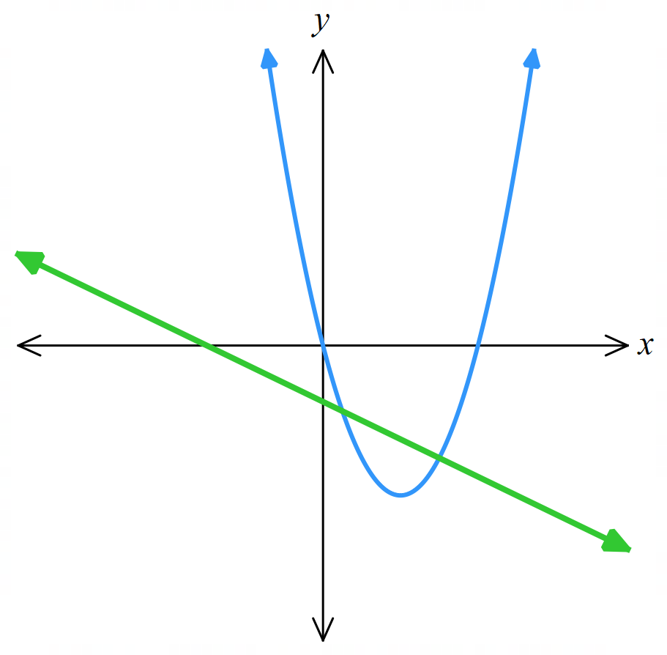
- When is the gradient of the tangent 0? What special significance does point have on your graph?  $$f'(x) = 2x - 4 = 0$$  $$x = 2$$  This is the turning point (minimum) of the parabola. | - Find the equation of the normal to the tangent at $x=3$, and sketch it on your graph.  $$At x=3:f'(3)=2,f(3)=-3$$  $$Normal gradient = -1/2$$  $$y-(-3)=-\frac{\left(x-3\right)}{2}$$  $$x+2y+3=0$$

Mastery
- We can bypass the quotient rule by splitting a fraction.
  - Find constants $a$ and $b$ such that $\frac{x}{x+1}$ $=a+$ $\frac{b}{x+1}$

$$\frac{x}{x+1}=\frac{ax+a+b}{x+1}$$
$$x=ax+a+b$$
By equating coefficients, $a=1, a+b=0$
$$∴a=1, b=-1$$
  - Hence differentiate $y=$ $\frac{x}{x+1}$
From part a, this is the same as differentiating
$$y=1+\frac{-1}{x+1}$$
$$y^{'}=\frac{1}{{\left(x+1\right)}^{2}}$$

- Consider $f\left(x\right)=\frac{\sqrt{x}+1}{x-1}$
  - Show that $\frac{\sqrt{x}+1}{x-1}=\frac{1}{\sqrt{x}-1}$.
$$\frac{\sqrt{x}+1}{x-1}=\frac{\sqrt{x}+1}{\left(\sqrt{x}-1\right)\left(\sqrt{x}+1\right)}$$
$$=\frac{1}{\sqrt{x}-1}$$
  - Hence differentiate $f\left(x\right).$
$$f^{'}\left(x\right)=\frac{-1}{2\sqrt{x}{\left(\sqrt{x}-1\right)}^{2}}$$

- Consider the function $f\left(x\right)=$ $\frac{x^{2}}{x-1}$.
  - Show that $f\left(x\right)=x+1+$ $\frac{1}{x-1}$.
$$\frac{x^{2}}{x-1}=\frac{x^{2}-1+1}{x-1}$$
$$=\frac{x^{2}-1}{x-1}+\frac{1}{x-1}$$
$$=\frac{\left(x-1\right)\left(x+1\right)}{x-1}+\frac{1}{x-1}$$
$$=x+1+\frac{1}{x-1}$$

  - Hence, differentiate $f\left(x\right).$
$$f^{'}\left(x\right)=1-\frac{1}{{\left(x-1\right)}^{2}}$$

- By first simplifying the expression, differentiate $f\left(x\right)=$ $\frac{x^{4}-1}{x-1}$.
$$\frac{x^{4}-1}{x-1}=\frac{\left(x^{2}-1\right)\left(x^{2}+1\right)}{x-1}$$
$$=\frac{\left(x-1\right)\left(x+1\right)\left(x^{2}+1\right)}{x-1}$$
$$=\left(x+1\right)\left(x^{2}+1\right)$$
$$=x^{3}+x^{2}+x+1$$
$$f^{'}\left(x\right)=3x^{2}+2x+1$$

- Differentiate $f\left(x\right)=$ $\frac{x-1}{\sqrt{x}+1}$ by first rationalising the denominator.

$$\frac{x-1}{\sqrt{x}+1}=\frac{\left(x-1\right)\left(\sqrt{x}-1\right)}{\left(\sqrt{x}+1\right)\left(\sqrt{x}-1\right)}$$
$$=\frac{\left(x-1\right)\left(\sqrt{x}-1\right)}{x-1}$$
$$=\sqrt{x}-1$$
$$f^{'}\left(x\right)=\frac{1}{2\sqrt{x}}$$

  - Expand and simplify $\left(x-1\right)\left(1+x+x^{2}+x^{3}+x^{4}\right)$.

$$x^{5}-1$$
  - Hence differentiate $\frac{x^{5}-1}{x-1}$ with respect to $x$.
$$\frac{x^{5}-1}{x-1}=\frac{\left(x-1\right)\left(1+x+x^{2}+x^{3}+x^{4}\right)}{x-1}$$
$$=1+x+x^{2}+x^{3}+x^{\$}$$
$$∴\frac{d}{dx}\left(\frac{x^{5}-1}{x-1}\right)=1+2x+3x^{2}+4x^{3}$$

- The line $x+y+2=0$ is a tangent to $y=x^{3}-4x$ at $P$. Find the coordinates of $P$.

$$y=-x-2$$
So $y^{'}=-1$
$$y^{'}=3x^{2}-4$$
$$-1=3x^{2}-4$$
$$x=±1$$
Sub into cubic equation to find possible coordinates of $P$.
Two possible coordinates of $P$ are $\left(1,-3\right)$ or $\left(-1, 3\right)$
Only $\left(1,-3\right)$ lies on the line $x+y+2=0$
$$∴P\left(1,-3\right)$$

Applications of Differentiation to Geometry Problems

- Review
- Find the points of intersection of a line and a curve.
- $y = x+2$ and  $$y=x²-2x+2$$ | - $y=2x+1$ and  $$y=x^{3}-3x^{2}+2x+1$$

- Find the $x$ and $y$ intercepts of a line.
- $3x+4y=12$ | - $y=-2x+8$

- Find the equation of the tangent and normal to these curves at the given point.
- $y=x²-4x+3$ at $x=2$ | - $y=2x^{3}-3x^{2}+1$ at $x=-1$

- Find the area of the triangle described by these coordinates, given that the lines are perpendicular to each other.
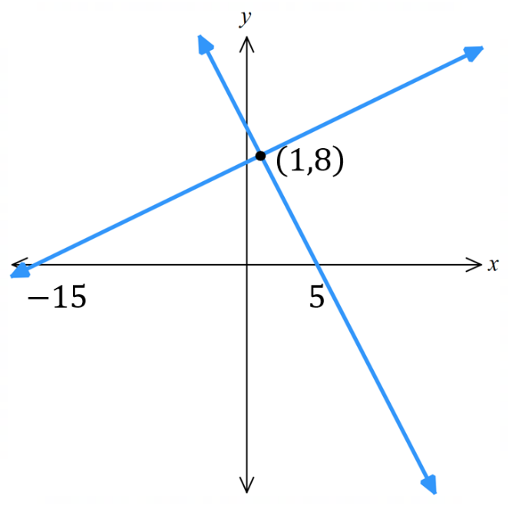 | 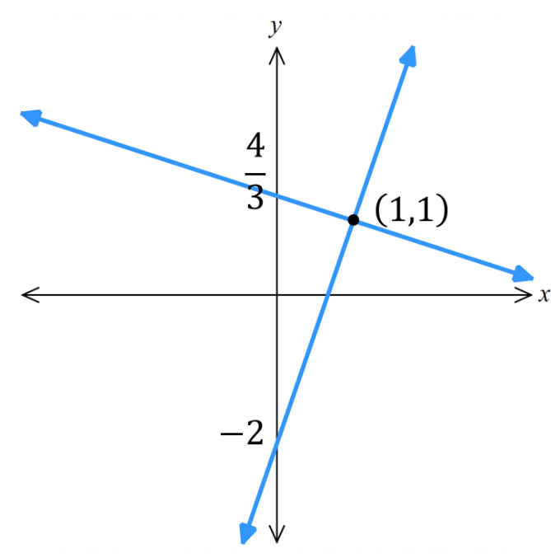

Development

  - Show that the line $y=3$ meets the parabola $y=4-x²$ at $D(1, 3)$ and $E(-1, 3).$

$$3=4-x^{2}$$
$$x=1, -1$$
$$∴\left(1,3\right), \left(-1,3\right)$$
  - Find the equations of the tangents to $y=4-x²$ at $D$ and $E$,
and find the point where these tangents intersect.
Start by sketching the situation.
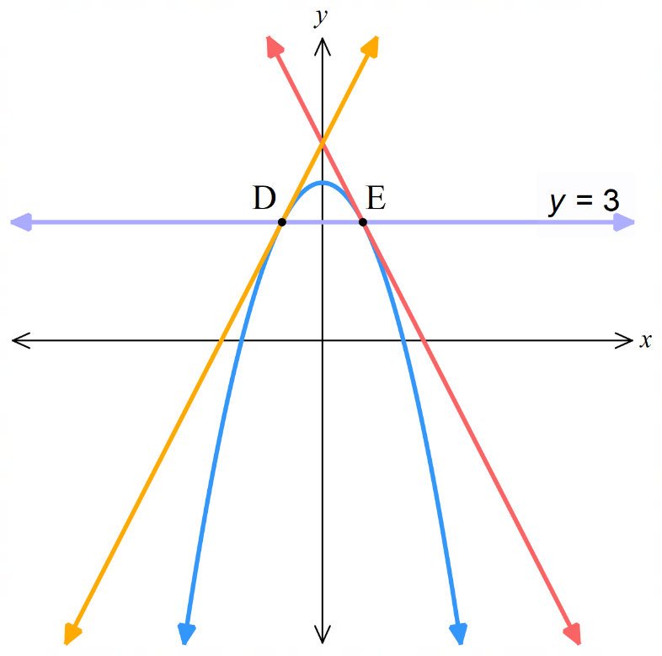
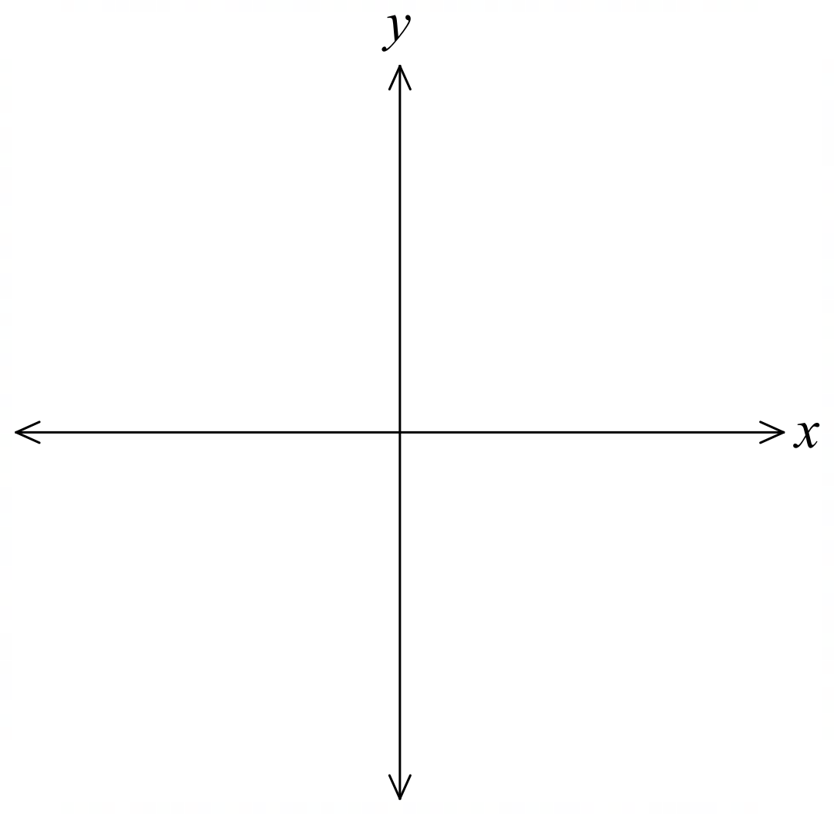

$$y=-2x+5, y=2x+5,$$
$$\left(0,5\right)$$

  - Find the equation of the tangent to $f(x)=10x-x^{3}$ at the point $P(2, 12)$.
  - Find the points $A$ and $B$ where the tangent meets the $x$-axis and $y$-axis respectively.
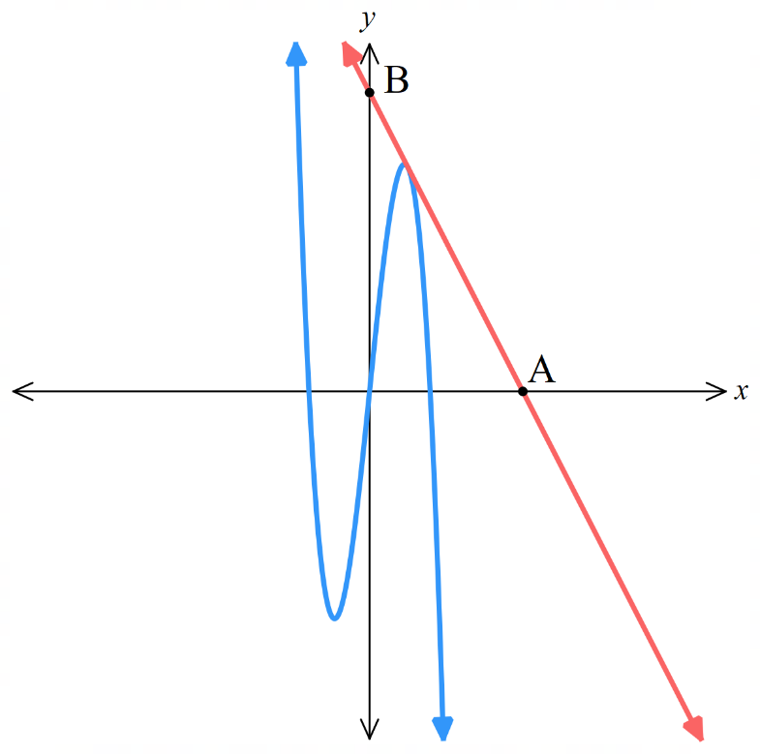
  - Sketch the situation, then find the length of $AB$ and the area of $△OAB$.

$$a) y=-2x+16$$
$$b) A\left(8,0\right), B\left(0,16\right)$$
$$c) AB=8\sqrt{5} units, Area=64 u^{2}$$

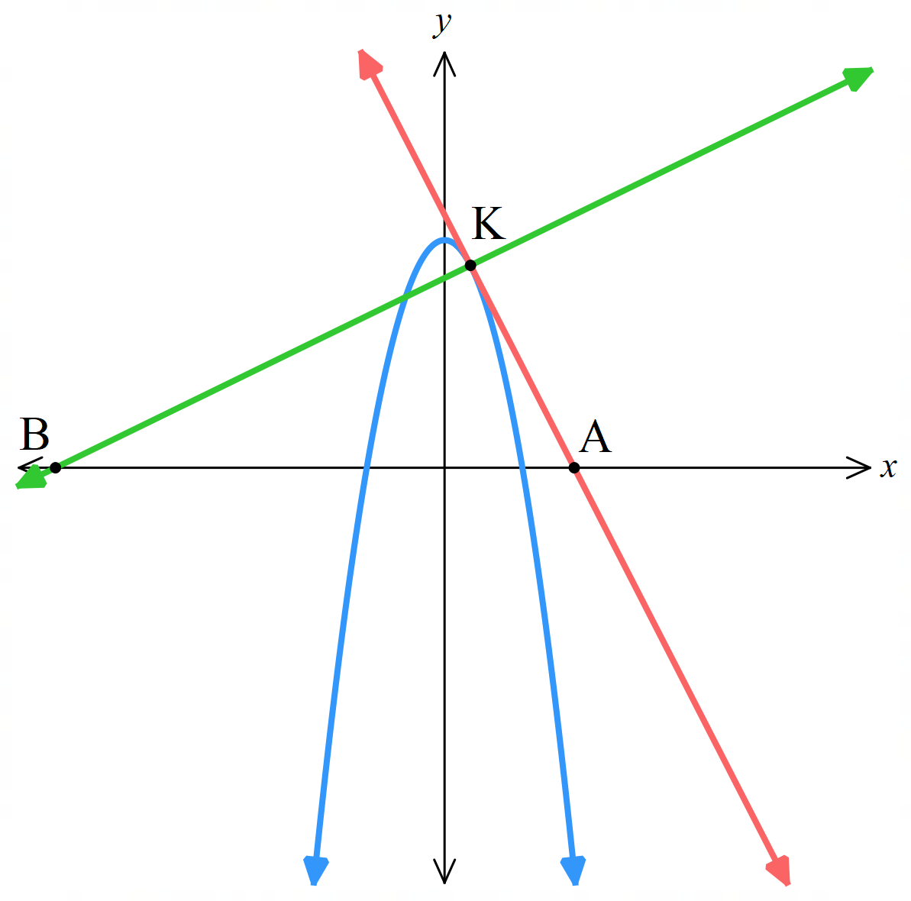
- The tangent and normal to $f(x)=9-x^{2}$ at the point $K(1, 8)$ meet the $x$-axis at $A$ and $B$ respectively. Sketch the situation, find the equations of the tangent and normal, find the coordinates of $A$ and $B$, and hence find the length $AB$ and the area of $△AKB$.

$$y=-2x+10, y=\frac{x}{2}+\frac{15}{2}$$
$$A\left(5,0\right), B\left(-15,0\right)$$
$$AB=20 units$$
$$Area=80 u^{2}$$
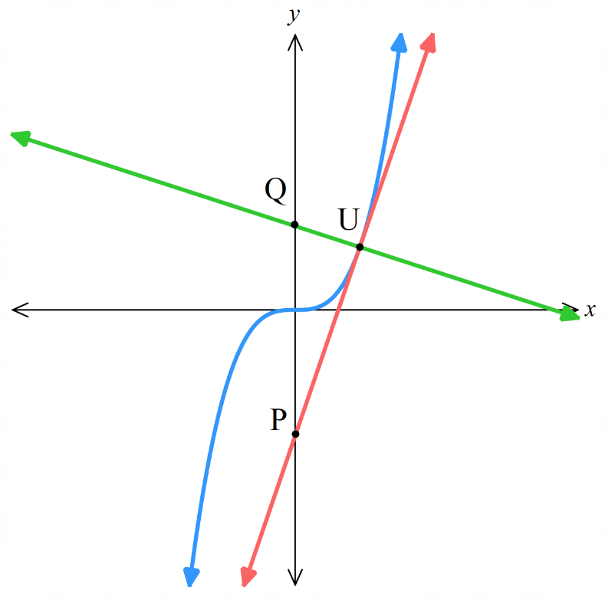
- The tangent and normal to the cubic $f(x)=x^{3}$ at the point $U(1, 1)$ meet the $y$-axis at $P$ and $Q$ respectively. Sketch the situation and find the equations of the tangent and normal.
Find the coordinates of $P$ and $Q$, and the area of $△QUP$.

$$y=3x-2$$
$$y=-\frac{x}{3}+\frac{4}{3}$$
$$P\left(0,-2\right)$$
$$Q\left(0, \frac{4}{3}\right)$$
$$Area=\frac{5}{3} u^{2}$$

  - Show that the tangents at the $x$-intercepts of $f(x)=x²-4x-45$ have opposite gradients.

$$f^{'}\left(x\right)=2x-4$$
$$f\left(x\right)=\left(x-9\right)\left(x+5\right)$$
$$f^{'}\left(9\right)=14, f^{'}\left(-5\right)=-14$$
  - Find the vertex of the parabola and use symmetry to explain geometrically why the result in part a has occurred.

The vertex is at $x=2$.
– 5 and 9 are equal distance from the vertex at $x=2$.
The parabola is symmetrical about its axis of symmetry at $x=2$, the tangents at $x=-5$ and $x=9$ are reflections of each other,
hence their equal but opposite gradients.

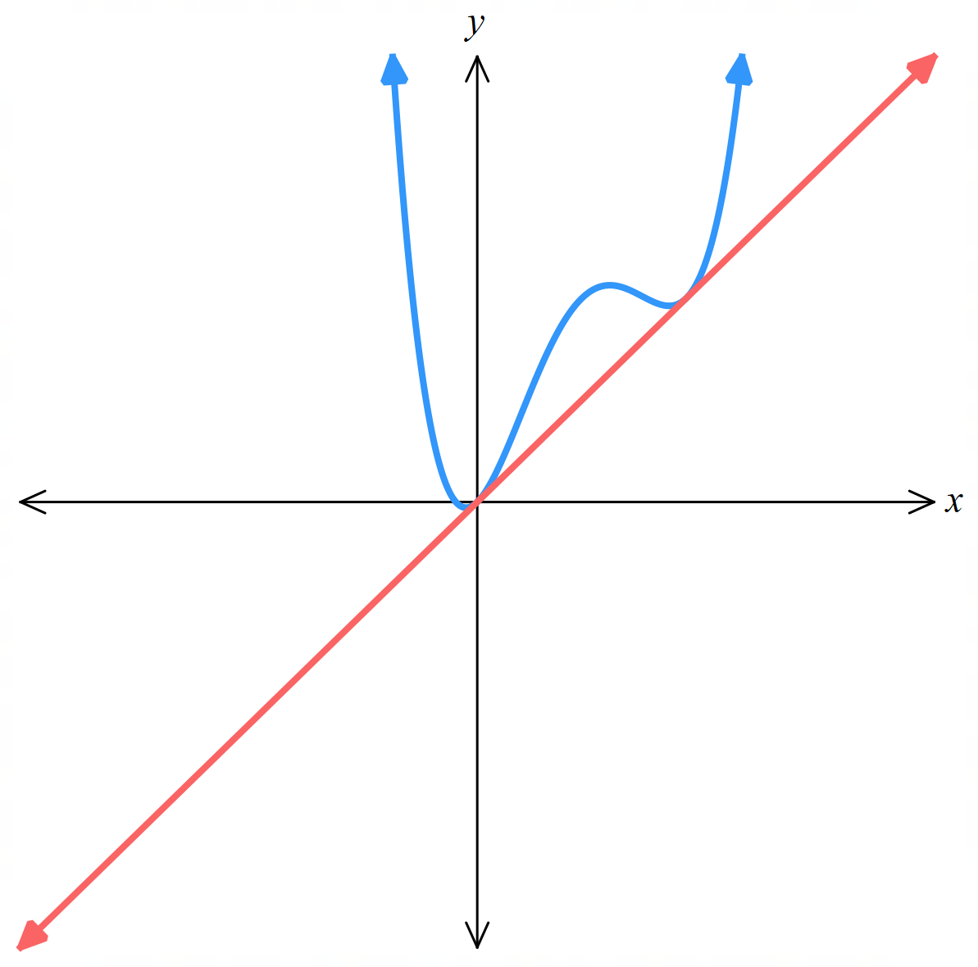
- Find the tangent to the curve $y=x⁴-4x³+4x²+x$ at the origin, and show that this line is also the tangent to the curve at the point (2, 2).

$$y^{'}=4x^{3}-12x^{2}+8x+1$$
$$at x=0, y^{'}=1$$
$$y-0=1\left(x-0\right)$$
Tangent at origin is $y=x$
$$at x=2, y^{'}=4{\left(2\right)}^{3}-12{\left(2\right)}^{2}+8\left(2\right)+1=1$$
$$y-2=1\left(x-2\right)→y=x$$
$$again, the tangent at x=2 is y=x$$
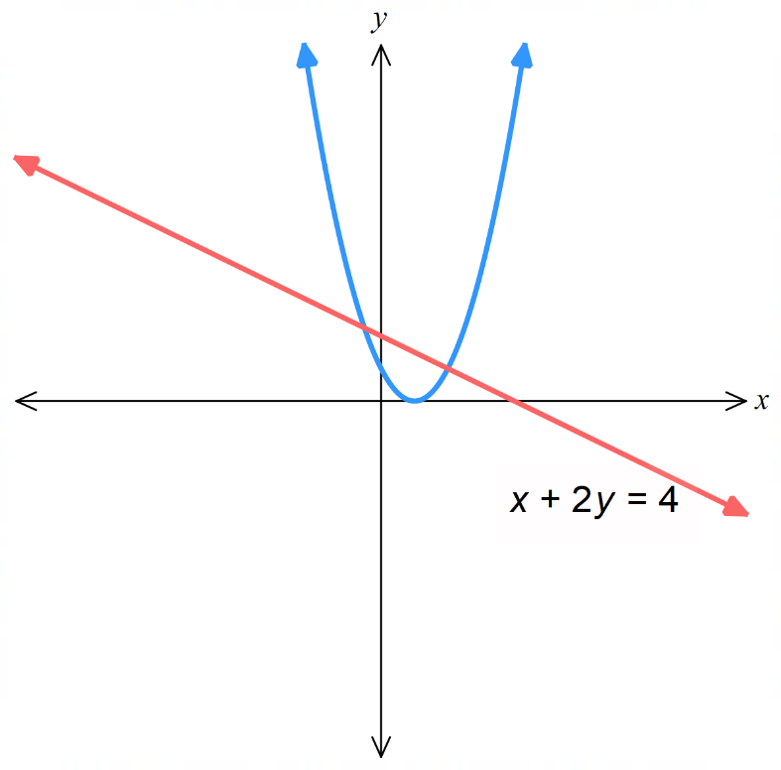
- Find the points where the line $x+2y=4$ cuts the parabola $y=(x-1)².$
Show that the line is the normal to the curve at one of these points.

Points of intersection at $\left(-\frac{1}{2},\frac{9}{4}\right)$ and $\left(2,1\right)$
The gradient of $x+2y=4$ is $-\frac{1}{2}$
$$f^{'}\left(2\right)=2$$
Therefore $x+2y=4$ is normal to the tangent of $y={\left(x-1\right)}^{2}$ at $x=2$

  - Sketch the graph of $y=\sqrt{x}$
  - Find the equation of the normal to the curve at $x=1$.
  - The normal intersects the $x$-axis and $y$-axis at $A$ and $B$ respectively.
Sketch this and find the coordinates of $A$ and $B$.
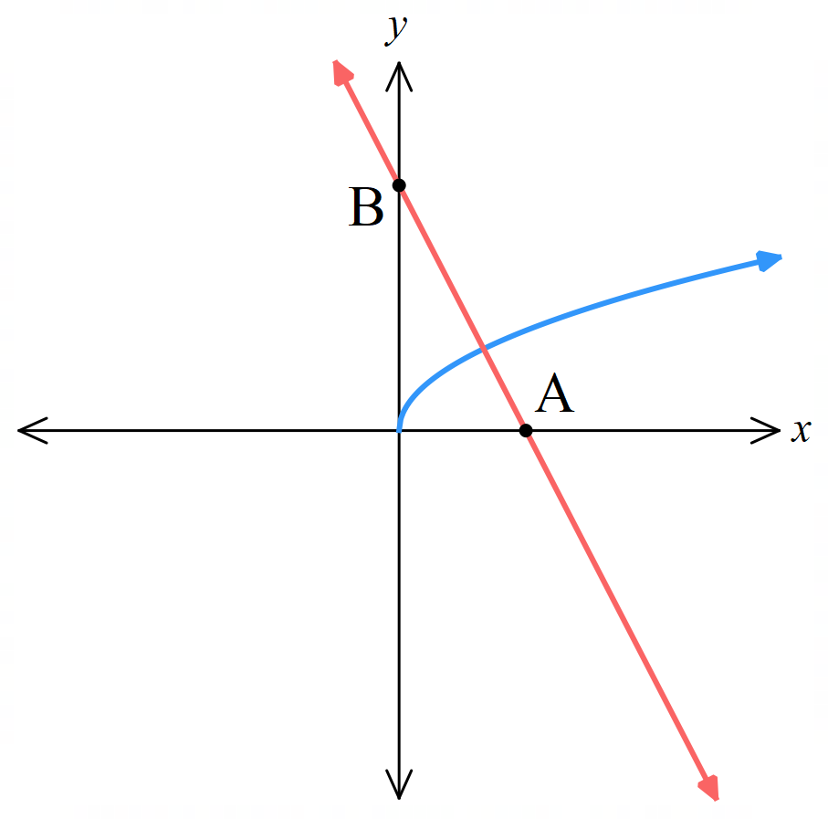
  - Find the area of $ΔOAB$, where $O$ is the origin.

Normal equation: $y=-2x+3$
$$A\left(\frac{3}{2},0\right), B\left(0,3\right)$$
$$\frac{9}{4} {units}^{2}$$

  - The tangent at $T(a, a²)$ to $y = x²$ meets the $x$-axis at $U$ and the $y$-axis at $V$.
Find the equation of this tangent and show that $△OUV$ has area $\left|\frac{a^{3}}{4}\right|$ square units.

$$y=2ax-a^{2}$$
$$U\left(\frac{a}{2},0\right), V=\left(0,-a^{2}\right)$$
$$A=\frac{bh}{2}=\left|\frac{\frac{a}{2}×-a^{2}}{2}\right|=\left|\frac{a^{3}}{4}\right|$$
We take the absolute value because even if the coordinate is negative, the distance is always positive.

  - Hence find the coordinates of $T$ for which this area is $31.25$ units².
$$\left|\frac{a^{3}}{4}\right|=31.25$$
$$±\frac{a^{3}}{4}=31.25$$
$$a=±5$$
$$T=\left(5,25\right) or \left(-5,25\right)$$

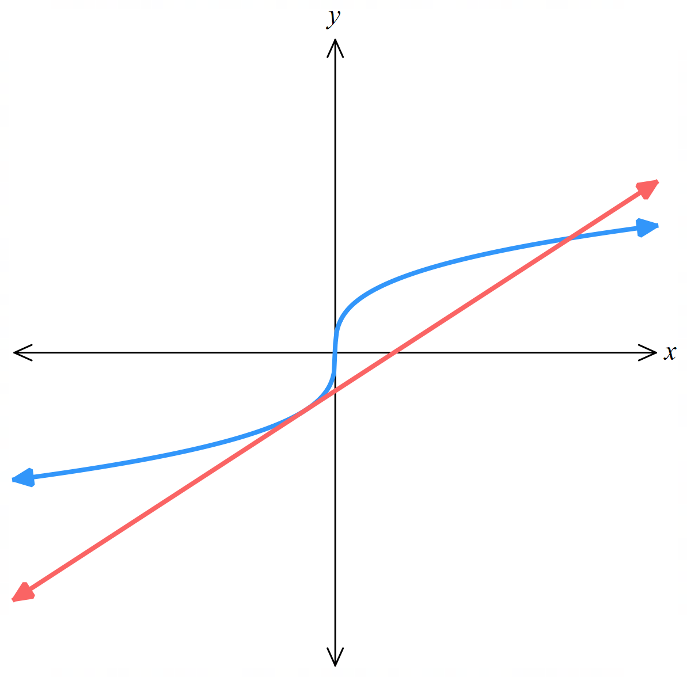
- Show that the tangent to $y=\sqrt[3]{x}$ at $T\left(-1,-1\right)$ meets the curve again at $\left(8,2\right)$.
not to scale
$$\frac{dy}{dx}=\frac{1}{3}x^{-\frac{2}{3}}=\frac{1}{3x^{\frac{2}{3}}}$$
At T(-1,-1):
$$\frac{dy}{dx}=\frac{1}{3{\left(-1\right)}^{\frac{2}{3}}}=\frac{1}{3}$$
Tangent equation at T(-1,-1):
$$y - \left(-1\right)=\frac{1}{3}\left(x - \left(-1\right)\right)$$
$$y =\frac{x}{3} -\frac{2}{3}$$
Find intersection with curve:
$$\sqrt[3]{x}=\frac{x}{3} -\frac{2}{3}$$
From here, you can simply substitute $x=8$ into the above equation to show that LHS = RHS and hence $x=8$, $y=2$ is a point of intersection.
Extension students may be asked the same question without being given the coordinates; to do so, we solve the equation by cubing both sides.
$$x={\left(\frac{x}{3}-\frac{2}{3}\right)}^{3}→x=\frac{1}{27}{\left(x-2\right)}^{3}$$
Expanding and moving all terms to one side: $-x^{3}+6x^{2}+15x+8=0$
Using factor theorem to find solutions, $P\left(8\right)=0$ so $x=8$ is a point of intersection.

- HSC Sample Advanced Question Band 4
At which point on the curve $y=2x^{2}-11x+3$ can a tangent be drawn such that it is inclined $135°$ when it crosses the $x$-axis?

$$\frac{dy}{dx}= 4x - 11 = - 1$$
$$x=2.5$$
Substitute $x=2.5$ into original equation: $y=-12$
$$\left(2.5,-12\right)$$
- HSC Sample Advanced Question Band 4
  - Find the equations of the tangents to the curve $y=x^{2}-3x$ at the points where the curve cuts the $x$-axis.
  - Where do the tangents intersect?
$a) y=x\left(x-3\right)$, $x$-intercepts at 0 and 3.
$$y^{'}=2x-3$$
Tangent 1: $y^{'}\left(0\right)=-3$
$$y-0=-3\left(x-0\right)$$
$$y=-3x$$
Tangent 2: $y^{'}\left(3\right)=3$
$$y-0=3\left(x-3\right)$$
$$y=3x-9$$
b) Intersection points:
$$-3x=3x-9$$
$$x=\frac{3}{2}$$
$$substitute x=\frac{3}{2} into tangent equation: y=-\frac{9}{2}$$
$$\left(\frac{3}{2}, -\frac{9}{2}\right)$$

  - Show that the tangents to $f\left(x\right)=$ $\frac{12}{x}$ at $M\left(2,6\right)$ and $T\left(-2,-6\right)$ are parallel.
  - Find the tangents at $M\left(2,6\right)$ and $N\left(6,2\right)$ and their point of intersection.
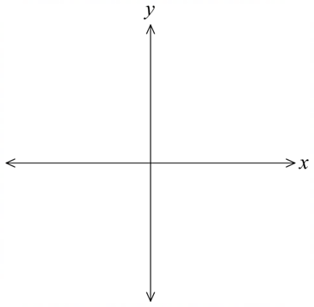
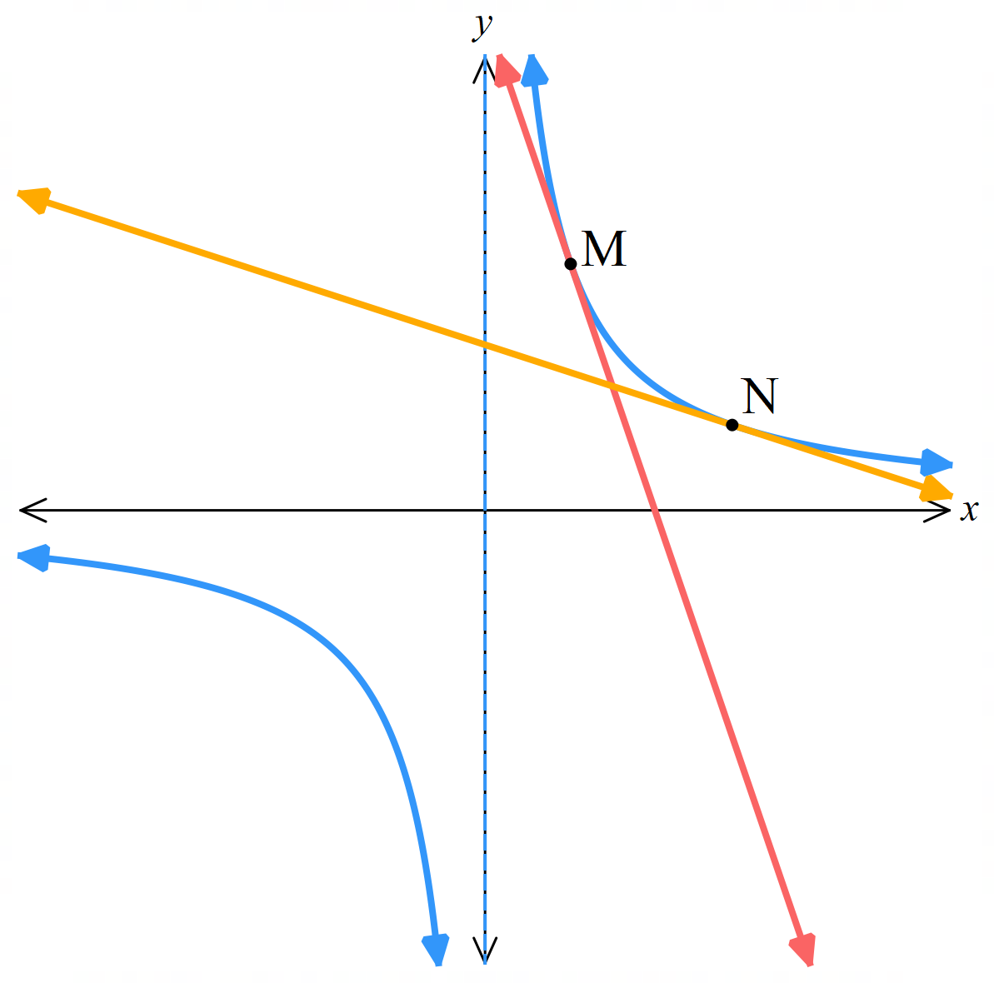
  - Sketch the situation in part b.

$$a) f'(x) = -\frac{12}{x^{2}}$$
$$f^{'}\left(2\right)=f^{'}\left(6\right)=-3$$
Both gradients are – 3, so the tangents are parallel.
b) Tangent at M: $y=-3x+12$
Tangent at N: $y=-\frac{1}{3}x+4$
They intersect at $\left(3,3\right)$

Mastery
- 2010 HSC Advanced Band 5
The parabola shown in the diagram is the graph $y=x^{2}$. The points $\left(-1,1\right)$ and $\left(2,4\right)$ lie on the parabola.
  - Find the equation of the tangent to the parabola at $A$.
  - Let $M$ be the midpoint of $AB$. There is a point $C$ such that the tangent at $C$ is parallel to $AB$.
Show that $MC$ is a vertical line.
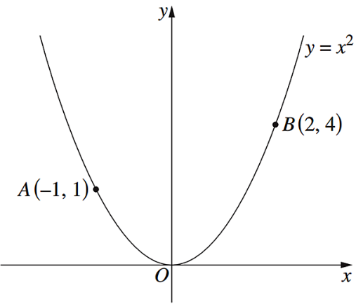
  - The tangent at $A$ meets the line $MC$ at $T$. Show that $BT$ is tangent to the parabola.
a) Find equation of tangent at A(-1,1):
$$\frac{dy}{dx}=2x$$
$$At A\left(-1,1\right):\frac{dy}{dx}=2\left(-1\right)=-2$$
Tangent: $y-1=-2\left(x-\left(-1\right)\right)$
$$y=-2x-1$$
b) Show MC is vertical:
$$M = midpoint of AB = \left(\frac{-1+2}{2},\frac{1+4}{2}\right) = (0.5, 2.5)$$
For tangent at C parallel to AB:
$$Slope of AB =\frac{4-1}{2-\left(-1\right)}=1$$
$$At point C\left(c, c^{2}\right):\frac{dy}{dx}=2c=1$$
∴ c = 0.5, so C = (0.5, 0.25)
MC connects (0.5, 2.5) and (0.5, 0.25)
Same $x$-coordinate ∴ MC is vertical
c) Show BT is tangent:
Tangent at A: $y = -2x - 1$
Line MC: $x = 0.5$
Intersection T: $x=0.5, y=-2(0.5)-1=-2$
∴ $T = (0.5, -2)$
Slope of BT = $\frac{-2-4}{0.5-2}$ $=4$
$$At B\left(2,4\right):\frac{dy}{dx}=2(2)=4$$
Since slope of BT equals $\frac{dy}{dx}$ at B, BT is tangent to parabola
- The equation of the tangent to the curve $y=x^{3}+ax^{2}+bx+4$ at the point $x=2$ is $y=x-4$.
Find $a$ and $b$.
$$y^{'}=3x^{2}+2ax+b$$
When $x=2, y^{'}=1$
$$y^{'}\left(2\right)=12+4a+b=1$$
$$∴4a+b=-11$$
The tangent point lies on both curves, so at $x=2, y=2-4=-2$
$$y\left(2\right)=8=4a+2b+4=-2$$
$$∴4a+2b=-14$$
Solving simultaneously,
$$a=-2, b=-3$$

  - Find the $x$-coordinates of the points $P$ and $Q$ on $y={\left(x-7\right)}^{2}+3$ such that the tangents at $P$ and $Q$ have gradients 1 and $-1$.
$$\frac{dy}{dx}= 2(x - 7)$$
$$Finding P: 2\left(x-7\right)=1; x=\frac{15}{2}$$
$$Finding Q: 2\left(x-7\right)=-1; x=\frac{13}{2}$$
  - The tangents and normal at $P$ and $Q$ form a square.
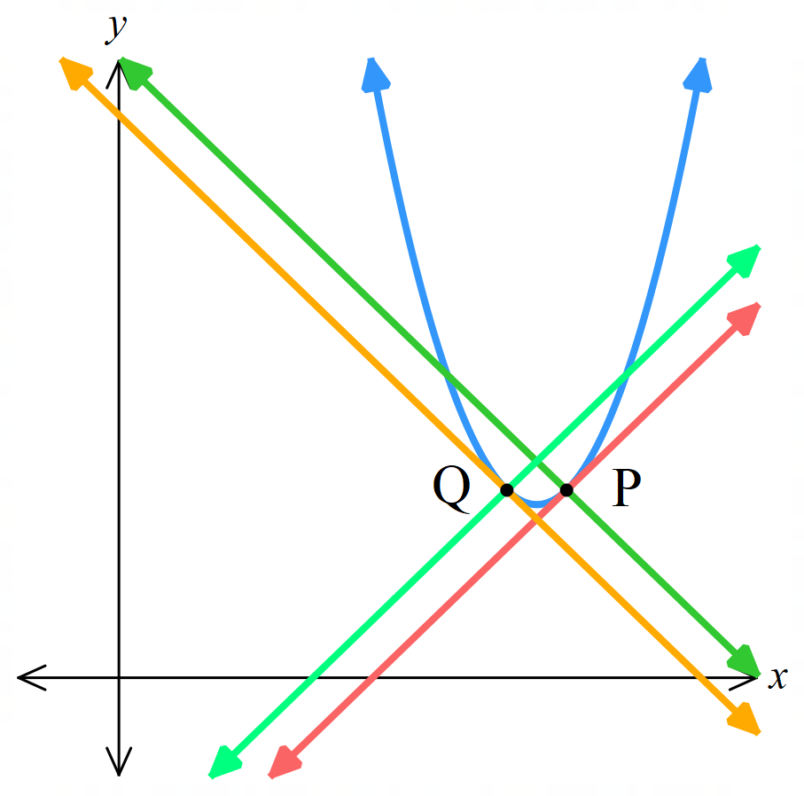
Show that it has area 0.5 sq units.

$$P: \left(\frac{15}{2},\frac{13}{4}\right), Q: \left(\frac{13}{2},\frac{13}{4}\right)$$
PQ is a diagonal of the square. The other diagonal is equal.
PQ is a horizontal line, so distance PQ = $\frac{15}{2}-\frac{13}{2}$ $= 1$
Using rhombus formula $A=\frac{1×1}{2}=\frac{1}{2}$
Alternate method is to find the equations of the tangents and normal,
find points of intersection of the tangents and normals,
then calculate the side length of the square to find area,
which takes much longer.

  - Differentiate the semicircle $y=\sqrt{169-x^{2}}.$
  - Find the equation of the tangent at $P(12, 5)$.
  - Find the $x$-intercept and $y$-intercept of the tangent.
  - Find the area of the triangle enclosed by the tangent and the two axes.
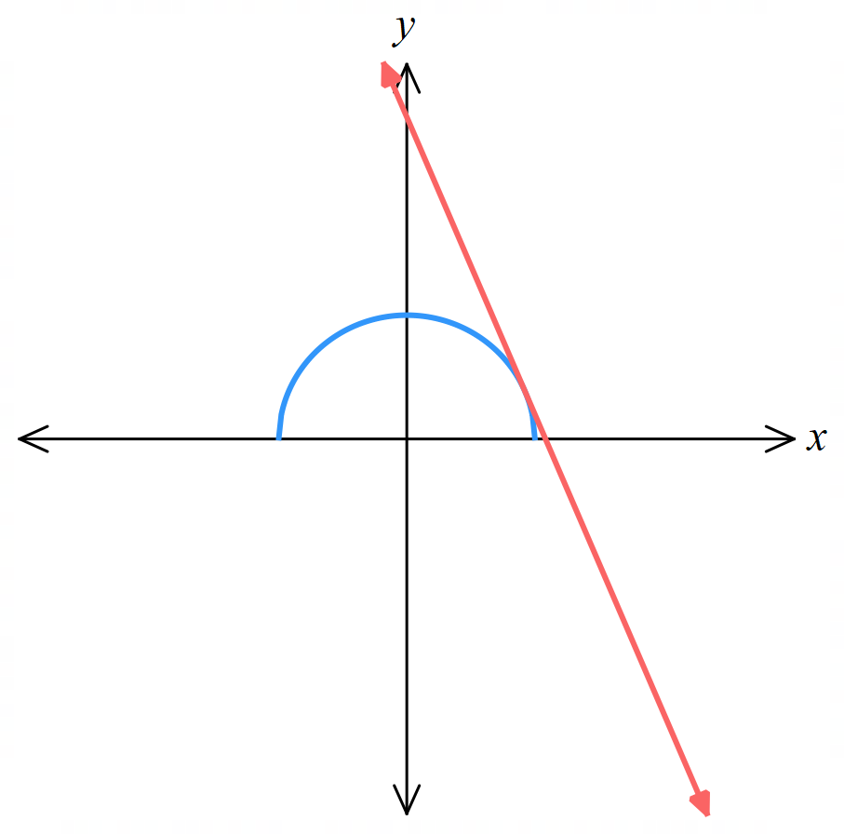
  - Find the perimeter of this triangle.
$$a) y={\left(169 - x^{2}\right)}^{\frac{1}{2}}$$
$$\frac{dy}{dx} =\frac{1}{2}{\left(169 - x^{2}\right)}^{-\frac{1}{2}}(-2x)=-x{\left(169 - x^{2}\right)}^{-\frac{1}{2}}$$
b) At P(12, 5):
$$\frac{dy}{dx}= -12{\left(169 - 144\right)}^{-\frac{1}{2}}=-\frac{12}{5}$$
$$Tangent: y = -\frac{12}{5}x +\frac{169}{5}$$
$$Normal: y =\frac{5x}{12}$$
$$c) x intercept: 0 = -\frac{12}{5}x +\frac{169}{5} → x =\frac{169}{12}$$
$$yintercept: y =\frac{169}{5}$$
$$d) Triangle vertices: (0, 0), \left(\frac{169}{12}, 0\right), \left(0,\frac{169}{5}\right)$$
$$Area = \left(\frac{1}{2}\right)\left(\frac{169}{12}\right)\left(\frac{169}{5}\right) =\frac{{169}^{2}}{120}$$
$$e) Base =\frac{169}{12}, height =\frac{169}{5}$$
$$Hypotenuse = \sqrt{{\left(\frac{169}{12}\right)}^{2}+ {\left(\frac{169}{5}\right)}^{2}}=\frac{2197}{60}$$
$$Perimeter =\frac{169}{12}+\frac{169}{5} +\frac{2197}{60}=\frac{169}{2}$$

  - What is the domain of $y=x\sqrt{1-x^{2}}$?
  - Differentiate $y=x\sqrt{1-x^{2}}$ and combine terms using a common denominator.
  - Find points on the curve where the tangent is horizontal.
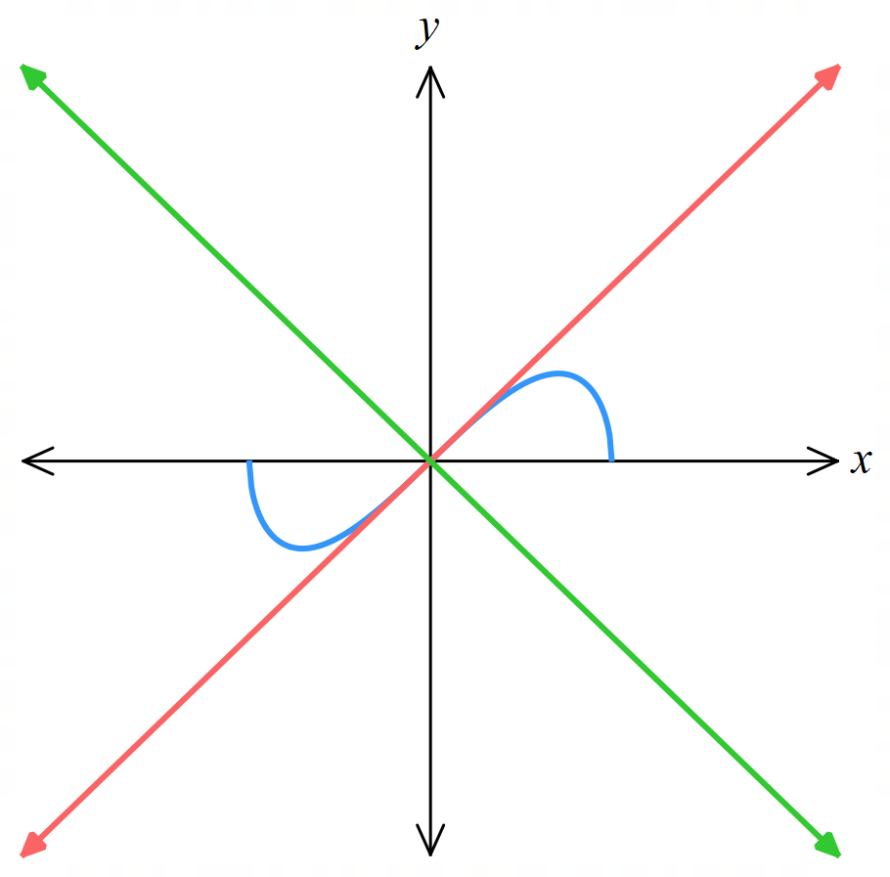
  - Find the tangent and normal at the origin.

$$a) -1≤x≤1$$
$$b) \frac{1-2x^{2}}{\sqrt{1-x^{2}}}$$
$$c) \left(\frac{1}{\sqrt{2}},\frac{1}{2}\right) and \left(-\frac{1}{\sqrt{2}}, -\frac{1}{2}\right)$$
$$d) y=x, y=-x$$

  - Differentiate $y=k\left(x-α\right)\left(x-β\right)$ using the product rule.
  - Show that the tangents at the $x$-intercepts have opposite gradients.
  - Show the tangents meet at point $M$ whose $x$-coordinate is the average of the $x$-intercepts.
  - Find the point $V$ where the tangent is horizontal.
  - Show that $M$ is vertically above or below $V$ and twice as far from the $x$-axis.
$$a)\frac{dy}{dx}=k\left(2x-α-β\right)$$  $$b) intercepts are at x=α and x=β$$  $$at x=α,\frac{dy}{dx}=k\left(α-β\right)$$  $$at k=β,\frac{dy}{dx}=k\left(β-α\right)$$  $$=-k\left(α-β\right)$$  $$∴opposite gradients at intercepts$$  c) Tangent at $(α,0):y=k(α-β)(x-α)$  Tangent at $(β,0):y=-k(α-β)(x-β)$  Point of intersection: $k\left(α-β\right)\left(x-α\right)=-k(α-β)(x-β)$  $$x-α=-x+β$$  $$x=\frac{α+β}{2}$$  $∴$ Tangents at intercepts meet the average of the intercepts. | $$d) Tangent horizontal when k\left(2x-α-β\right)=0$$  $$2x-α-β=0$$  $$2x=α+β$$  $$x=\frac{α+β}{2}$$  Substitute $x=$ $\frac{α+β}{2}$ into the parabola equation for $y$-coord of point $V$:  $$V=\left(\frac{α+β}{2},-\frac{k{\left(α - β\right)}^{2}}{4}\right)$$  $$e) Same x coordinate as M, so vertically above or below M.$$  Substitute $x=$ $\frac{α+β}{2}$ into either tangent equation for $y$-coord of point $M:$  $$M=\left(\frac{α+β}{2},-\frac{k{\left(α - β\right)}^{2}}{2}\right)$$  The $y$ value for $M$ is twice that of $V,$ so it is twice as far from the $x$-axis.
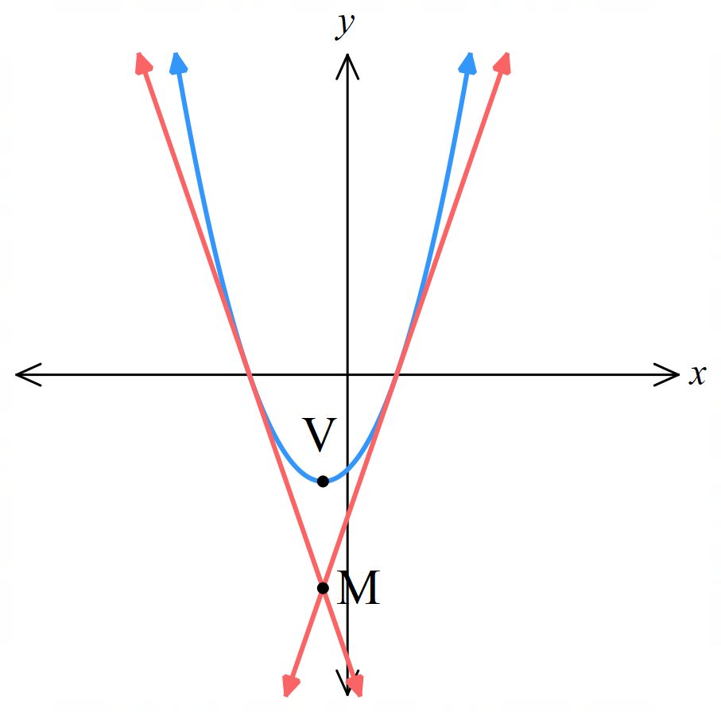

  - Differentiate $f\left(x\right)={\left(ax+b\right)}^{n}$, where $a$ and $b$ are constants, and $n=2,3,4…$
$$f^{'}\left(x\right)=an{\left(ax+b\right)}^{n-1}$$
  - Find $f\left(-\frac{b}{a}\right)$. What does this mean geometrically for when $x=-$ $\frac{b}{a}$?
$$f\left(-\frac{b}{a}\right)=0 for all n$$
The $x$-intercept always exists at $x=-$ $\frac{b}{a}$
  - Find $f^{'}\left(-\frac{b}{a}\right)$. What does this mean geometrically?
$$f^{'}\left(-\frac{b}{a}\right)=0 for n≥2$$
This means the gradient of the tangent is always 0 at the $x$-intercept.
So, the $x$-intercept of a power function is always either a turning point or a point of inflection.
https://www.desmos.com/calculator/z5ddikxtza

  - Differentiate $y=\sqrt{2x+1}.$

$$y^{'}=\frac{1}{\sqrt{2x+1}}$$
  - Show that $y×y^{'}=1$

$$y⋅y^{'}=\sqrt{2x+1}⋅\frac{1}{\sqrt{2x+1}}=1$$
  - When $y→∞,$ what happens to the value of $y'$? What does this mean geometrically?

$$y^{'}=\frac{1}{y}→0 as y→∞$$
As the curve’s $y$-value increases, the tangent becomes more horizontal.
  - Verify this by sketching $y=\sqrt{2x+1}$ using Desmos.

- Find the gradient of the tangent to $y=\sqrt{4-x^{2}}$ at $x=2$. Explain your answer.

$$y^{'}=-\frac{x}{\sqrt{4-x^{2}}}$$
This is undefined at $x=2$
This is because the tangent to the semicircle at $x=2$ is a vertical line.
https://www.desmos.com/calculator/bwo9dgalgd

- Let $n$ be any positive integer. Show that $f\left(x\right)=x{\left(x^{2}+1\right)}^{n}$ will never be horizontal at any points on the curve.
$$f^{'}\left(x\right)=\left(x^{2}+ 1\right)ⁿ^{-1}\left[x^{2}\left(1 + 2n\right)+ 1\right]$$
Tangent horizontal when $\left(x^{2}+ 1\right)ⁿ^{-1}\left[x^{2}\left(1 + 2n\right)+ 1\right]=0$
By null factor law, either
$$\left(x^{2}+ 1\right)ⁿ^{-1}=0 or x^{2}\left(1 + 2n\right)+ 1=0$$
$$\left(x^{2}+ 1\right)ⁿ^{-1}≠0 as x^{2}+1>0$$
$$x^{2}\left(1 + 2n\right)+ 1≠0 as x^{2}\left(1 + 2n\right)≥0$$
Therefore, no real numbers exist for $\left(x^{2}+ 1\right)ⁿ^{-1}\left[x^{2}\left(1 + 2n\right)+ 1\right]=0$, tangent can never be horizontal.

https://www.desmos.com/calculator/pfzjlbxnuj

  - Show that $P\left(cp,\frac{c}{p}\right)$, where $c$ is a constant, lies on the hyperbola $xy=c^{2}$.
  - Draw a sketch of the hyperbola and label any point $P$ on the curve.
  - Show that the tangent at $P$has equation $x+p^{2}y=2cp$. Draw the tangent on your sketch.
  - The tangent intersects the $x$ and $y$ axes at $A$ and $B$ respectively. Show that the area of $ΔOAB$ will always be the same, regardless of where the tangent was drawn.

$$a) cp×\frac{c}{p}=c^{2}$$
$$b) https://www.desmos.com/calculator/jqbeenn5b3$$
$$c) y=\frac{c^{2}}{x}$$
$$y^{'}=-\frac{c^{2}}{x^{2}}$$
$$at x=cp, y^{'}=-\frac{c^{2}}{c^{2}p^{2}}=-\frac{1}{p^{2}}$$
$$y-\frac{c}{p}=-\frac{1}{p^{2}}\left(x-cp\right)$$
$$p^{2}y-cp=-x+cp$$
$$∴ x+p^{2}y=2cp$$
$$d) x int at:x=2cp$$
$$y int at: p^{2}y=2cp→y=\frac{2c}{p}$$
$$A=\frac{1}{2}\left(2cp\right)\left(\frac{2c}{p}\right)=2c^{2}$$
Area will always be $2c^{2}$

